CA416 Software Engineering Lab File

SP23,2k22 batch,II Semester,MCA

Name- Mohit Sharma

Roll No- MCA/10012/22



**Department of Computer Science and Engineering**

**Birla Institute of Technology, Mesra, Ranchi - 835215 (India)**

**COURSE INFORMATION**

**Course code: IT306**

**Course title: Software Engineering Lab**

**Pre-requisite(s):**

**Credits:** 2

**Class schedule per week: 3 lectures**

**Course Objectives**

This course enables the students:

|  |  |
| --- | --- |
| A. | To Understand the concepts of Requirements Engineering Process |
| B. | To learn about various UML diagrams |
| C. | To Understand architectural design. |
| D. | To explore various software testing tools |

**Course Outcomes**

After the completion of this course, students will be able to:

|  |  |
| --- | --- |
| **1** | **To prepare an IEEE-SRS from the given case study and draw use case diagrams, DFD, architectural design, and also prepare use case description document.** |
| **2** | **To create a complete UML class diagram for the given case study and apply iterative process to refine the class diagram if there is a change in requirements** |
| **3** | **To create sequence, collaboration and state chart diagrams to analyse the dynamic behaviour of the system**. |
| **4** | **To create activity diagram, component and deployment diagram to analyse the environmental and deployment view of the system.** |
| **5** | **Test the programs using software testing tools Like JUnit,Selenium,TestNG,JMeter,Cucumber,LDRA and Jumble** |

**Mapping between Course Objectives and Course Outcomes**

|  |  |  |  |  |
| --- | --- | --- | --- | --- |
| **Course Outcome** | **Course Objectives** | | | |
| **A** | **B** | **C** | **D** |
| **1** | H | H | H | L |
| **2** | H | H | L | L |
| **3** | H | H | L | L |
| **4** | H | H | M | L |
| **5** | H | L | L | H |

**Reference Books:**

R1: Learning UML 2.0 by Russ Miles & Kim Hamilton (O’Reilly), 2006

R2: Design Patterns: Elements of Reusable Object-Oriented Software with Applying UML and Patterns: An Introduction to Object-Oriented Analysis and Design and the Unified Process by Erich Gamma, Richard Helm, Ralph Johnson, and John Vlissides, 2003.

R3: UML for java Programmers by Robert Ceil Martin, Prentice Hall

R4: UML Distilled, third edition, Martin Fowler

R5: Presentations used in the Course.

**COURSE PLAN**

**Department:** Computer Science and Engineering

**Course:** IT306 Software Engineering Lab

**Academic Year: MO**2022

**Class:** BE (CSE)

**Semester:** VI

**Course Coordinator:** Dr.K.Sridhar Patnaik

|  |  |  |  |  |
| --- | --- | --- | --- | --- |
| **SI.**  **no.** | **Lecture/Labs**  **Serial no.s** | **Topic(s) to be covered** | **Preferred Book(s)** | **Total no.**  **of**  **Lecture/Lab Hr.s** |
|  | 1-2 | Preparation of an IEEE-SRS from the given case study and draw use case diagrams, DFD and also prepare use case description document. | R1-R5 | 6 |
|  | 3-4 | Create a complete UML class diagram for the given case study and apply iterative process to refine the class diagram if there is a change in requirements | R1-R5 | 6 |
|  | 5-6 | Create sequence, collaboration and state chart diagrams to analyse the dynamic behaviour of the system. | R1-R5 | 6 |
|  | 7-8 | Able to create activity diagram, component and deployment diagram to analyse the environmental and deployment view of the system | R1-R5 | 6 |
|  | 9-10 | Explore software testing tools | R1-R5 | 6 |

**Lab Assignments(M.Marks-50)**

**Questions:1)Extract the Business functions from the given case study and draw a use case diagram. Also prepare a use case description document. Draw the architectural design of the system.(3+3+2)**

**2) Draw a DFD for the given case study. Also prepare an IEEE-SRS .(2+4)**

**3) Do class analysis along with associations to prepare an initial class diagram.(2)**

**4) Refine the class diagram to get the final complete class diagram.(2)**

**5) Using Use case diagram and class diagram construct the interaction diagrams like sequence, collaboration and state chart diagram.(4)**

**6) Draw an Activity diagram to capture the various activities involved while capturing the behavioural aspect of the system.(2)**

**7) Draw the component and deployment diagram to analyse the environmental and deployment view of the system.(2+2)**

**8) Learn and analyse the usage of software testing tools.: JUnit, Jmeter, Selenium,Jenkins,Maven, LDRA Etc(7)**

**9)Prototype development(10)**

**9) Submission of the soft copy of the lab file (5)**

**Contents**

|  |  |  |
| --- | --- | --- |
| **Assignment No** | **Date of Submission** | **Page No** |
| **Assignment No -1** | **/03/2023** | **7 to 10** |
| **Assignment No -2** | **/03/2023** | **11 to 23** |
| **Assignment No -3** | **/03/2023** | **23 to 25** |
| **Assignment No -4** | **/03/2023** | **25 to 26** |
| **Assignment No -5** | **/03/2023** | **26 to 30** |
| **Assignment No -6** | **/03/2023** | **30 to 32** |
| **Assignment No -7** | **/03/2023** | **32 to 34** |
| **Assignment No -8** | **/03/2023** |  |
| **Assignment No -9** | **/03/2023** |  |
|  |  |  |
|  |  |  |
|  |  |  |
|  |  |  |
|  |  |  |

**Case Study No and Title:** P12: Hospital Management System (HMS)

**Brief Description about the case study:**

Hospital Management System (HMS) is powerful, flexible, and easy to use system, which is very helpful in a hospital environment, in order to maintain a hospital efficiently. Hospital Management System designed for multi-specialty hospitals, to cover a wide range of hospital administration and management processes. It is an integrated end-to-end Hospital Management System (HMS) that provides relevant information across the hospital to support effective decision making for patient care, hospital administration and critical financial accounting, in a seamless flow.

In a HMS need to have entry of all the data related to patients, doctors, staffs, and administrator(s). Each patients admitted in the hospital needs to enter their personal information, which are accessible by authorized doctors and staffs. On the other hand, a patient should have access permission to download any medical report associated with him/her.

Billing process should be included in the system, such that it can easily be update after each payment.

Inputs:

•Hospital information (name, address, branch, department, facilities)

•Employee information (name, employee id, address, contact details)

•Doctor information (name, employee id, address, contact details, specialization, degrees)

•Patient information (name, id, address, age, payment, others)

Output:

•Patient details

•Patients list

•Receipt generation

•Report generation Constraints:

•All the users must register into the system though the web interface.

•All the users must login into the web interface through userid (must be unique) and password

•Patients should allow to get login him/her-self in order to collecting own information

•On login into the system, a doctor must be able to see the patients list under his/her observation

•One patient must not access the information of some other patients

•All the patients must be able to download all the medical report and bill as per his requirement by login into the system.

Add, delete, and update must be reflect immediately in the system

**Lab Assignment No.1) Extract the Business functions from the given case study and draw a use case diagram. Also prepare a use case description document. Draw the architectural design of the system.(3+3+2)**

**Solution:**

Business functions: -

* Log in
* Patient List
* Patient medical history
* Patient report
* Payment receipt

Actors: -

* Employee
* Doctor
* Patient

Use case Diagram:

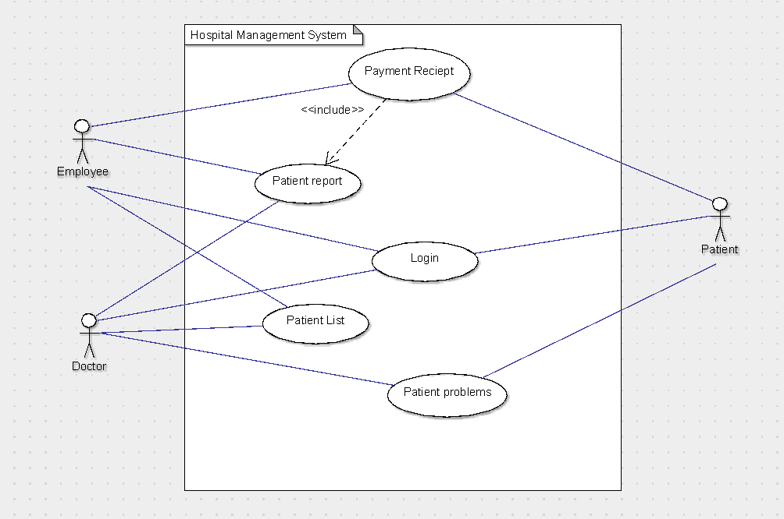

### **Use Case #1 (Patient List)**

|  |  |  |  |  |
| --- | --- | --- | --- | --- |
| **Use Case ID:** | P12 Hospital Management System | | | |
| **Use Case Name:** | Patient List | | | |
| **Process Owner:** | Mohit Sharma | | **Last Updated By:** | Mohit Sharma |
| **Date Created:** | 05/01/2023 | | **Date Last Updated:** | 19/01/2023 |
| **Business Actor:** | | Hospital Employee | | |
| **Description:** | | This use case describes the patient list generated. | | |
| **Preconditions:** | | Patients should register in the Hospital database. | | |
| **Postconditions:** | | Patient List generated Successfully. | | |
| **Performance Goal:** | | To generate a non-ambiguous patient list. | | |
| **Basic Workflow:** | | Actor Action: -   1. Patient Loas in and choose for appointment.   3) Employee logs in and checks for flagged patient.  5) Assign doctors according to patient problems. | | |
| System Response: -  2) Verify user and marks a flag.  4) System verifies employee and responds with flagged patient details.  6) System takes the entries generate a non-redundant patient list. | | |
| **Alternative Workflow:** | | Actor Action: -  1) Patient tries to log in with wrong id or password. | | |
| System Response: -  2) System responds with forgot details option. | | |
| **Category:** | | User goal | | |
| **Risks:** | | Users may fill in wrong details. | | |
| **Possibilities:** | | Patient may be an employee or a doctor. | | |
| **Special Requirements:** | | Patients need to register, login and choose for an appointment if not an existing user. | | |
| **Assumptions:** | | The patient is already registered and already chooses his/her appointment. | | |
| **Notes and Issues:** | | Patient must fill his correct and complete details | | |

### **Use Case #2 (Patient Report)**

|  |  |  |  |  |
| --- | --- | --- | --- | --- |
| **Use Case ID:** | P12 Hospital Management System | | | |
| **Use Case Name:** | Patient Report | | | |
| **Process Owner:** | Mohit Sharma | | **Last Updated By:** | Mohit Sharma |
| **Date Created:** | 05/01/2023 | | **Date Last Updated:** | 19/01/2023 |
| **Business Actor:** | | Doctor | | |
| **Description:** | | This use case describes the patient report generated. | | |
| **Preconditions:** | | Patients should be on the patient list. | | |
| **Postconditions:** | | Patient report generated Successfully. | | |
| **Performance Goal:** | | To generate a perfect report. | | |
| **Basic Workflow:** | | Actor Action: -   1. Patient Loas in and checks for appointment.   3) Doctor logs in to the system and checks the patient list.  5) Doctor diagnoses the patient and generates a medical report and saves it in the system.  7) Patient Logs in and request for medical report. | | |
| System Response: -   1. Verify user and respond back with the appointment.   4) System verifies doctor and responds with patient list.  6) System saves the changes in the data base.  8) System verify user and responds with medical report. | | |
| **Alternative Workflow:** | | Actor Action: -  1) Patient logs in and checks for appointment but date is passed.  System Response: -  2) System verifies user and response with reschedule option. | | |
| **Category:** | | User goal | | |
| **Risks:** | | System can show an incorrect report due to some bug. | | |
| **Possibilities:** | | In case of emergency, patients must be admitted without registration. | | |
| **Special Requirements:** | | Patients need to choose an appointment if not an emergency case. | | |
| **Assumptions:** | | The patient is already registered and already chooses his/her appointment. | | |
| **Notes and Issues:** | | Patient must fill his correct and complete details. | | |

Architectural Design:

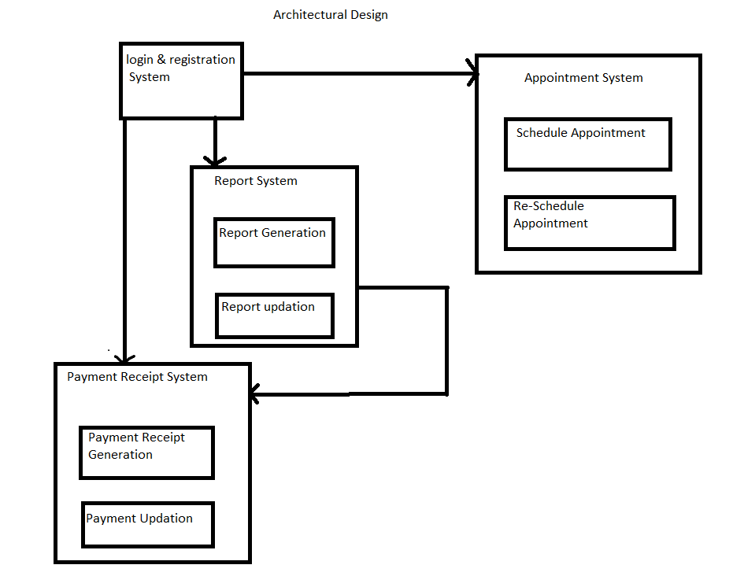

**Lab Assignment No. 2) Draw a DFD for the given case study. Also prepare an IEEE-SRS .(2+4)**

Solution: -

DFD Diagram

Level 0- Context diagram.

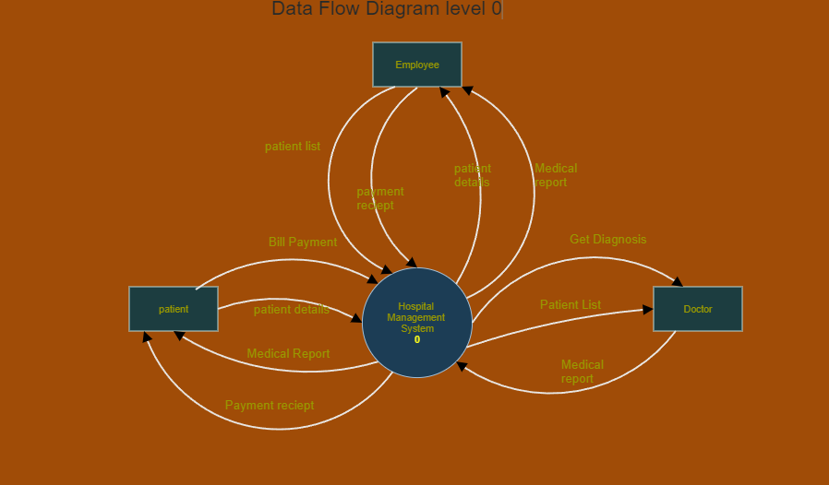

Level 1:

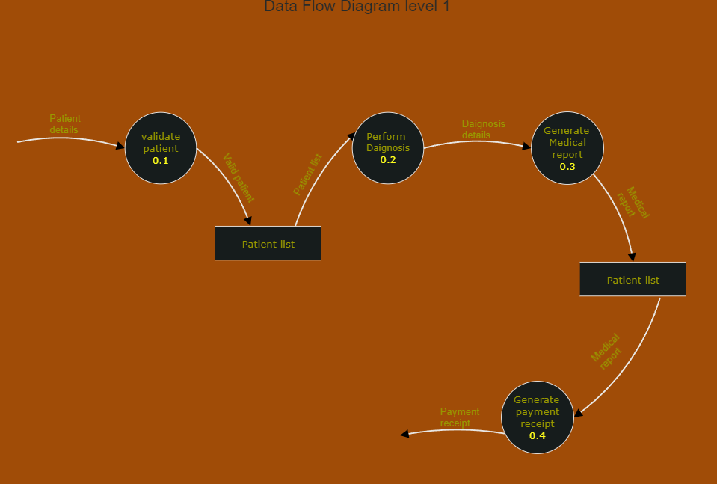

SRS Document:

**Software Requirements Specification**

**for**

**Hospital Management System**

**Version 1.0**

**Prepared by**

|  |  |  |
| --- | --- | --- |
| **Mohit Sharma** | **MCA/10012/22** | [**mca10012.22@bitmesra.ac.in**](mailto:mca10012.22@bitmesra.ac.in) |

|  |  |
| --- | --- |
| **Instructor:** | **Dr. K. Sridhar Patnaik** |
| **Course:** | **MCA** |

**Contents**

**CONTENTS** **II**

**REVISIONS** **II**

**1** **INTRODUCTION** **1**

1.1 Document Purpose 1

1.2 Product Scope 1

1.3 Intended Audience and Document Overview 1

1.4 Definitions, Acronyms and Abbreviations 1

1.5 Document Conventions 1

1.6 References and Acknowledgments 2

**2** **OVERALL DESCRIPTION** **2**

2.1 Product Overview 2

2.2 Product Functionality 3

2.3 Design and Implementation Constraints 3

2.4 Assumptions and Dependencies 3

**3** **SPECIFIC REQUIREMENTS** **4**

3.1 External Interface Requirements 4

3.2 Functional Requirements 4

3.3 Use Case Model 5

**4** **OTHER NON-FUNCTIONAL REQUIREMENTS** **6**

4.1 Performance Requirements 6

4.2 Safety and Security Requirements 6

4.3 Software Quality Attributes 6

**5** **OTHER REQUIREMENTS** **7**

**APPENDIX A – DATA DICTIONARY** **8**

**APPENDIX B - GROUP LOG** **9**

**Revisions**

|  |  |  |  |
| --- | --- | --- | --- |
| **Version** | **Primary Author(s)** | **Description of Version** | **Date Completed** |
| 1.0 | Mohit Sharma | Added an SRS for the project “Hospital Management System”. | 01/03/23 |

1. **INTRODUCTION**

# **Introduction**

## **Document Purpose**

The SRS describes the usage and scope for the Hospital Management System Developed in Java.

The purpose of the product is to provide the user-friendly, easy to use and interactive application to the Patient, Doctors and Hospital employee. The product can generate appointments, patient list, medical reports and payments accurately.

## **Product Scope**

Hospital Management System is powerful, flexible, and easy to use system, which is very helpful in a hospital environment, to maintain a hospital efficiently. Hospital Management System designed for multi-specialty hospitals, to cover a wide range of hospital administration and management processes.

It is an integrated end-to-end Hospital Management System that provides relevant information across the hospital to support effective decision making for patient care, hospital administration and critical financial accounting, in a seamless flow.

**2.OVERALL DETAILS**

# **Overall Description**

## **Product Overview**

Hospital Management System (HMS) is powerful, flexible, and easy to use system, which is very helpful in a hospital environment, to maintain a hospital efficiently. Hospital Management System designed for multi-specialty hospitals, to cover a wide range of hospital administration and management processes. It is an integrated end-to-end Hospital Management System (HMS) that provides relevant information across the hospital to support effective decision making for patient care, hospital administration and critical financial accounting, in a seamless flow.

In a HMS need to have entry of all the data related to patients, doctors, employees. Each patient admitted in the hospital needs to enter their personal information, which are accessible by authorized doctors and employees. On the other hand, a patient should have access permission to download any medical report associated with him/her. Billing process should be included in the system, such that it can easily be update after each payment.

## **Product Functionality**

### **Doctor Module:**

* Get Patient List.
* Generate Medical Report.

### **Employee Module:**

* Generate Patient List.
* Get Medical Report.
* Generate Payment Receipts.

### **Patient Module:**

* Choose Appointment.
* Get Diagnosis.
* Get Medical Reports.
* Get Payment Receipts.

**3.SPECIFIC REQUIREMENTS**

# **Specific Requirements**

## **External Interface Requirements**

### **User Interfaces**

User interface is designed in a user-friendly manner and the user, in another end he must give the order, for that he will interface with keyboard and mouse.

### **Hardware Interfaces**

1) OS windows 7 and above

2) Hard disk 512 GB

3) RAM - 4 GB

4) Keyboard Standard QWERTY keyboard for interface

5) Mouse Standard mouse with 2 buttons

### **Software Interfaces**

1) Front end Java language

2) IntelliJ IDEA Community Edition 2022.2.2.

## **Functional Requirements**

### **Doctor Module:**

* Get Patient List: - When Employee Generates patient list doctor gets a copy of the list of patients that are assigned to him/her.
* Generate Medical Report: - Doctor generates a medical report after diagnosis of the patient whose copy will be sent to the Employee to generate payment receipt.

### **Employee Module:**

* Generate Patient List: - When patient chooses for appointment the employee checks the patients details and accordingly generates a patient for various available doctors.
* Get Medical Report: -When doctor generates medical reports a copy get to the employee to generate payment receipt.
* Generate Payment Receipts: - After getting medical reports according to the test perform employee generates payment receipt.

### **Patient Module:**

* Choose Appointment: - patient chooses for appointment.
* Get Appointment Details: - patient gets details about the date, time and appointed doctor.
* Get Diagnosis: - patient visit doctor for diagnoses.
* Get Medical Reports: -After treatment patient gets a medical report.
* Get Payment Receipts: -After receiving the medical report patient then gets payment receipt which he/she pays.

## **Non-Functional Requirements**

### **Security**

* **Patient Identification: -** The system requires the patient to identify himself /herself using pc or phone.
* **Login ID: -** Any user who uses the system shall have a Logon ID and Password.
* **Modification: -**Any modification (insert, delete, update) for the Database shall be synchronized and done only by the administrator in the ward.
* **Employee**: -Employee shall be able to view all information in HMS, add new patients to HMS but shall not be able to modify any information in it.

**3.3.2 Performance Requirements**

* **Response Time: -**The system shall give responses in 1 second after checking the patient’s information.
* **Capacity: -** The System must support 1000 people at a time.
* **User-interface: -** The user-interface screen shall respond within 5 seconds.

…

## **Use Case Model**



### **Use Case #1 (Patient List)**

|  |  |  |  |  |
| --- | --- | --- | --- | --- |
| **Use Case ID:** | P12 Hospital Management System | | | |
| **Use Case Name:** | Patient List | | | |
| **Process Owner:** | Mohit Sharma | | **Last Updated By:** | Mohit Sharma |
| **Date Created:** | 05/01/2023 | | **Date Last Updated:** | 19/01/2023 |
| **Business Actor:** | | Hospital Employee | | |
| **Description:** | | This use case describes the patient list generated. | | |
| **Preconditions:** | | Patients should register in the Hospital database. | | |
| **Postconditions:** | | Patient List generated Successfully. | | |
| **Performance Goal:** | | To generate a non-ambiguous patient list. | | |
| **Basic Workflow:** | | Actor Action: -   1. Patient Loas in and choose for appointment.   3) Employee logs in and checks for flagged patient.  5) Assign doctors according to patient problems. | | |
| System Response: -  2) Verify user and marks a flag.  4) System verifies employee and responds with flagged patient details.  6) System takes the entries generate a non-redundant patient list. | | |
| **Alternative Workflow:** | | Actor Action: -  1) Patient tries to log in with wrong id or password. | | |
| System Response: -  2) System responds with forgot details option. | | |
| **Category:** | | User goal | | |
| **Risks:** | | Users may fill in wrong details. | | |
| **Possibilities:** | | Patient may be an employee or a doctor. | | |
| **Special Requirements:** | | Patients need to register, login and choose for an appointment if not an existing user. | | |
| **Assumptions:** | | The patient is already registered and already chooses his/her appointment. | | |
| **Notes and Issues:** | | Patient must fill his correct and complete details | | |

### **Use Case #2 (Patient Report)**

|  |  |  |  |  |
| --- | --- | --- | --- | --- |
| **Use Case ID:** | P12 Hospital Management System | | | |
| **Use Case Name:** | Patient Report | | | |
| **Process Owner:** | Mohit Sharma | | **Last Updated By:** | Mohit Sharma |
| **Date Created:** | 05/01/2023 | | **Date Last Updated:** | 19/01/2023 |
| **Business Actor:** | | Doctor | | |
| **Description:** | | This use case describes the patient report generated. | | |
| **Preconditions:** | | Patients should be on the patient list. | | |
| **Postconditions:** | | Patient report generated Successfully. | | |
| **Performance Goal:** | | To generate a perfect report. | | |
| **Basic Workflow:** | | Actor Action: -   1. Patient Loas in and checks for appointment.   3) Doctor logs in to the system and checks the patient list.  5) Doctor diagnoses the patient and generates a medical report and saves it in the system.  7) Patient Logs in and request for medical report. | | |
| System Response: -   1. Verify user and respond back with the appointment.   4) System verifies doctor and responds with patient list.  6) System saves the changes in the data base.  8) System verify user and responds with medical report. | | |
| **Alternative Workflow:** | | Actor Action: -  1) Patient logs in and checks for appointment but date is passed.  System Response: -  2) System verifies user and response with reschedule option. | | |
| **Category:** | | User goal | | |
| **Risks:** | | System can show an incorrect report due to some bug. | | |
| **Possibilities:** | | In case of emergency, patients must be admitted without registration. | | |
| **Special Requirements:** | | Patients need to choose an appointment if not an emergency case. | | |
| **Assumptions:** | | The patient is already registered and already chooses his/her appointment. | | |
| **Notes and Issues:** | | Patient must fill his correct and complete details. | | |

…

**4.OTHER NON-FUNCTIONAL REQUIREMENTS**

# **Other Non-functional Requirements**

## **Performance Requirements**

*<If there are performance requirements for the product under various circumstances, state them here and explain their rationale, to help the developers understand the intent and make suitable design choices. Specify the timing relationships for real time systems. Make such requirements as specific as possible. You may need to state performance requirements for individual functional requirements or features.*

*TODO: Provide performance requirements based on the information you collected from the client/professor. For example, you can say “P1. The secondary heater will be engaged if the desired temperature is not reached within 10 seconds”>*

## **Safety and Security Requirements**

*<Specify those requirements that are concerned with possible loss, damage, or harm that could result from the use of the product. Define any safeguards or actions that must be taken, as well as actions that must be prevented. Refer to any external policies or regulations that state safety issues that affect the product’s design or use. Define any safety certifications that must be satisfied. Specify any requirements regarding security or privacy issues surrounding use of the product or protection of the data used or created by the product. Define any user identity authentication requirements.*

*TODO:*

*Provide safety/security requirements based on your interview with the client - again you may need to be somewhat creative here. At the least, you should have some security for the mobile connection.*

## **Software Quality Attributes**

*<Specify any additional quality characteristics for the product that will be important to either the customers or the developers. Some to consider are: adaptability, availability, correctness, flexibility, interoperability, maintainability, portability, reliability, reusability, robustness, testability, and usability. Write these to be specific, quantitative, and verifiable when possible. At the least, clarify the relative preferences for various attributes, such as ease of use over ease of learning.*

*TODO: Use subsections (e.g., 4.3.1 Reliability, 4.3.2 Adaptability, etc…) provide requirements related to the different software quality attributes. Base the information you include in these subsections on the material you have learned in the class. Make sure, that you do not just write “This software shall be maintainable…” Indicate how you plan to achieve it, & etc…Do not forget to include such attributes as the design for change (e.g. adapting for different sensors and heating/AC units, etc.). Please note that you need to include* ***at least*** *2 quality attributes. You can Google for examples that may pertain to your system.>*

# **Other Requirements**

*<This section is* ***Optional.*** *Define any other requirements not covered elsewhere in the SRS. This might include database requirements, internationalization requirements, legal requirements, reuse objectives for the project, and so on. Add any new sections that are pertinent to the project.>*

**Data Dictionary: -**

|  |  |  |
| --- | --- | --- |
| **Class Name** | **Data Members** | **Member Functions** |
| **Admin:** |  |  |
|  |  | Task() |
| **Patient:** |  |  |
|  | Name: string | Get_address() |
|  | Id: int | Pay_bill() |
|  | Age: int |  |
|  | Maritial_status: string |  |
|  | Sex: string |  |
|  | Blood_group: string |  |
| **Task:** |  |  |
|  |  | Add_patient() |
|  |  | View_details() |
|  |  | Search() |
|  |  | Discharge() |
|  |  | Payment_receipt() |
| **Address:** |  |  |
|  | House_no: int |  |
|  | Street: int |  |
|  | City: string |  |
|  | State: string |  |
|  | Country: string |  |
| **Payment_Receipt:** |  |  |
|  | Treatment_charges: float | Total_amount() |
|  | Bed_charges: float |  |
|  | Other_charges: float |  |
|  | Amount: float |  |

**Data Flow Diagram: -**

Level 0 DFD



Level 1 DFD



**Lab Assignment No. 3) Do class analysis along with associations to prepare an initial class diagram.(2)**

Solution: -

Total Possible classes: -

1. Hospital
2. User
3. Patient
4. Doctor
5. Employee
6. Report
7. Patient history
8. Payment Receipt
9. New User
10. Existing User
11. Display
12. Patient List

Bad Classes: -

Redundant: -

* New user
* Existing user

Attribute: -

* Report
* Patient List

Vague: -

* Patient History
* Display

Good Classes: -

* Hospital
* User
* Patient
* Employee
* Doctor
* Payment receipt

Association: -

* User Can be a patient.
* User Can be a doctor.
* User Can be an employee.
* Hospital has employees.
* Hospital has doctors.
* Hospital has patients.
* Employee generates payment receipt.
* Employee handles many patients.
* Doctor diagnoses the patients.
* Patient gets a payment receipt.

Initial Class Diagram:

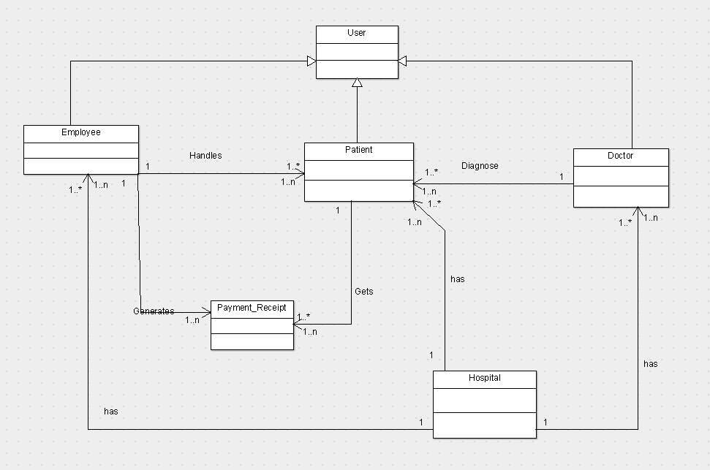

**Lab Assignment No. 4) Refine the class diagram to get the final complete class diagram.(2)**

Solution:

Class Diagram:

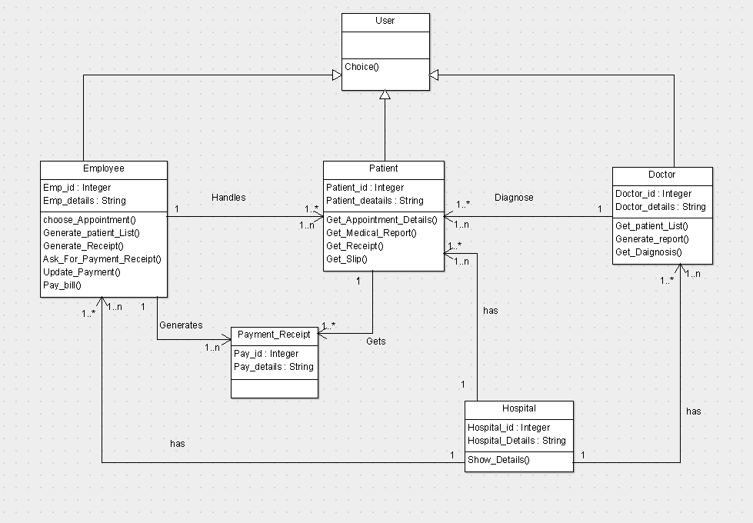

**Lab Assignment No. 5) Using Use case diagram and class diagram construct the interaction diagrams like sequence, collaboration and state chart diagram.(4)**

Solution:

Sequence Diagram:

For Patient List:

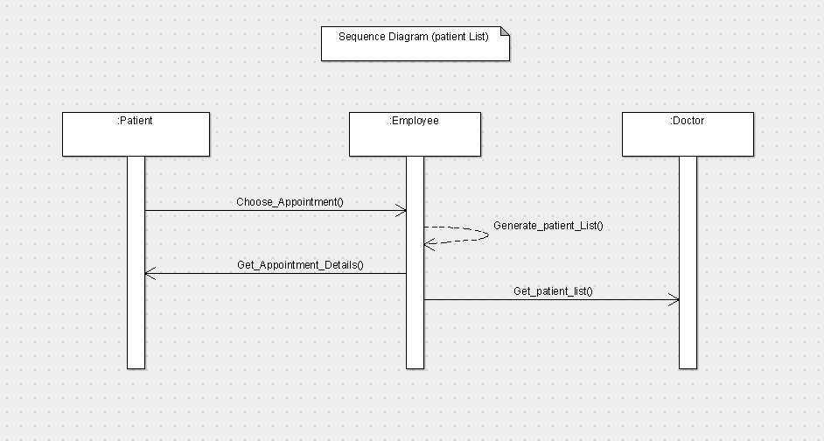

For Payment Receipt:

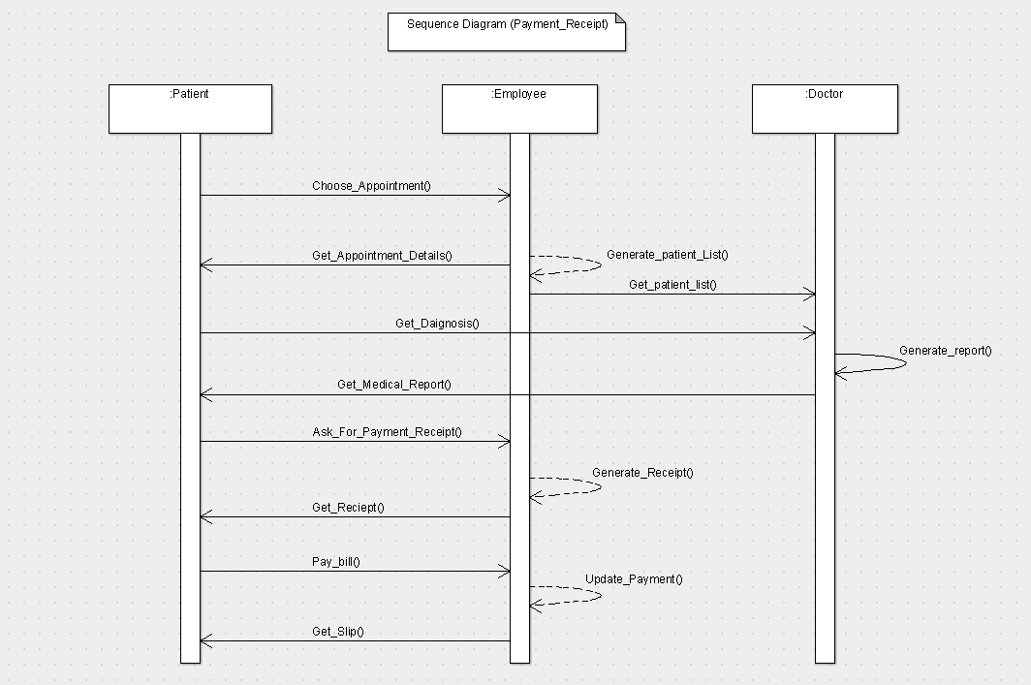

Collaboration Diagram:

For Patient List:

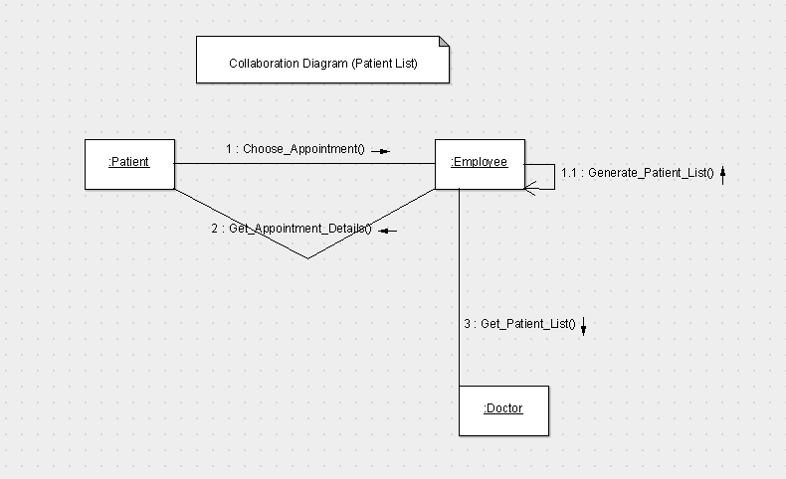

For Payment Receipt:

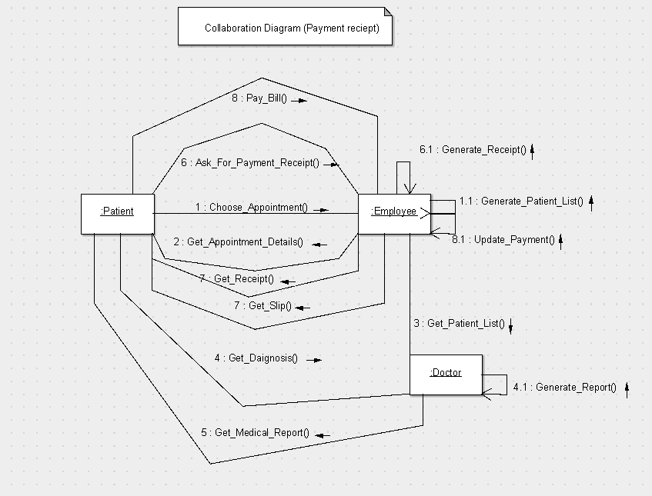

State chart Diagram for patient:

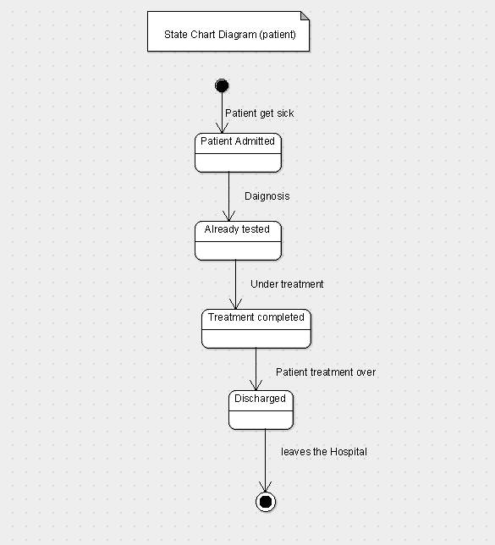

**Lab Assignment No. 6) Draw an Activity diagram to capture the various activities involved while capturing the behavioural aspect of the system.(2)**

Solution:

Activity Diagram:

For Patient List:

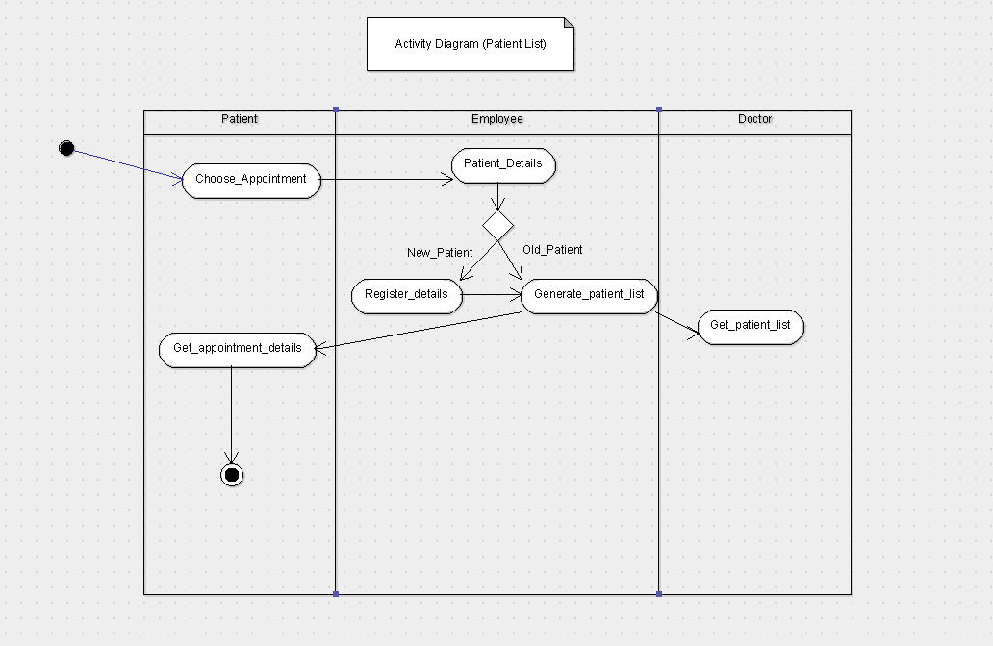

For Payment Receipt:

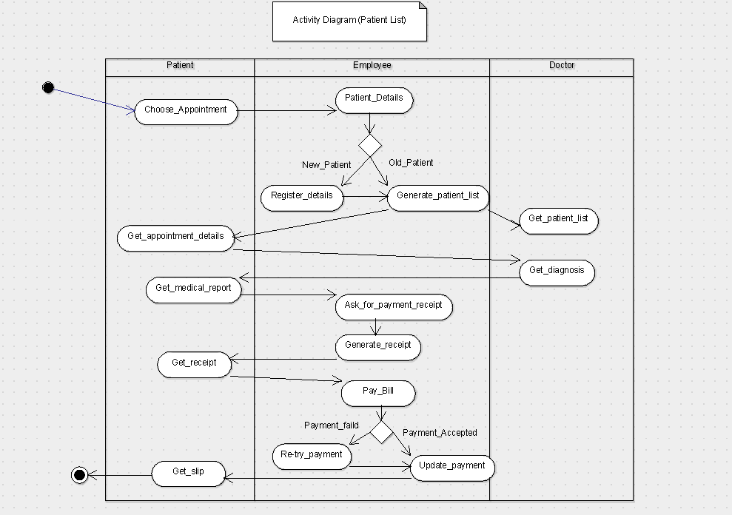

**Lab Assignment No. 7) Draw the component and deployment diagram to analyse the environmental and deployment view of the system.(2+2)**

Solution:

Component Diagram:

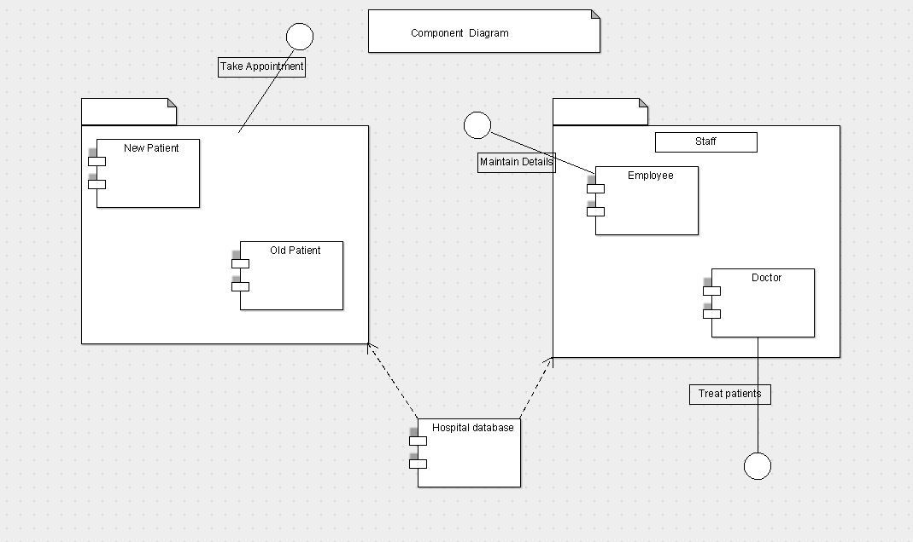

Deployment Diagram:

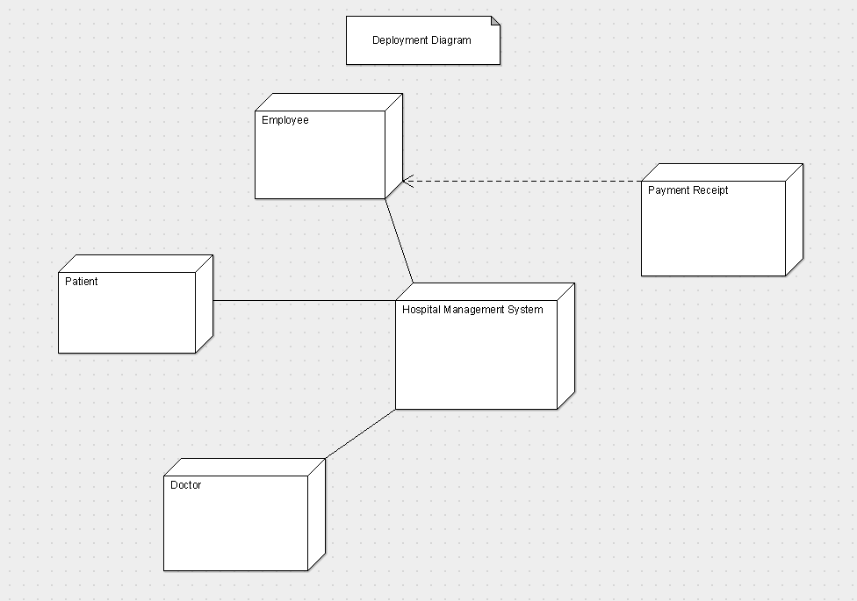

**Lab Assignment No. 8) Learn and analyse the usage of software testing tools.: JUnit, Jmeter, Selenium,Jenkins,Maven, LDRA Etc(7)**

Solution:

Jmeter:

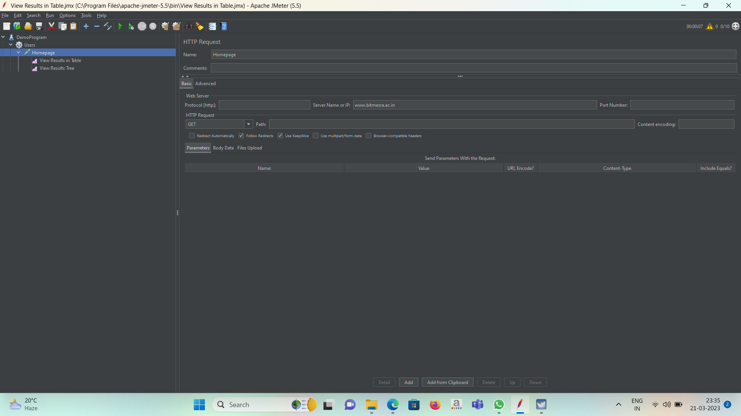

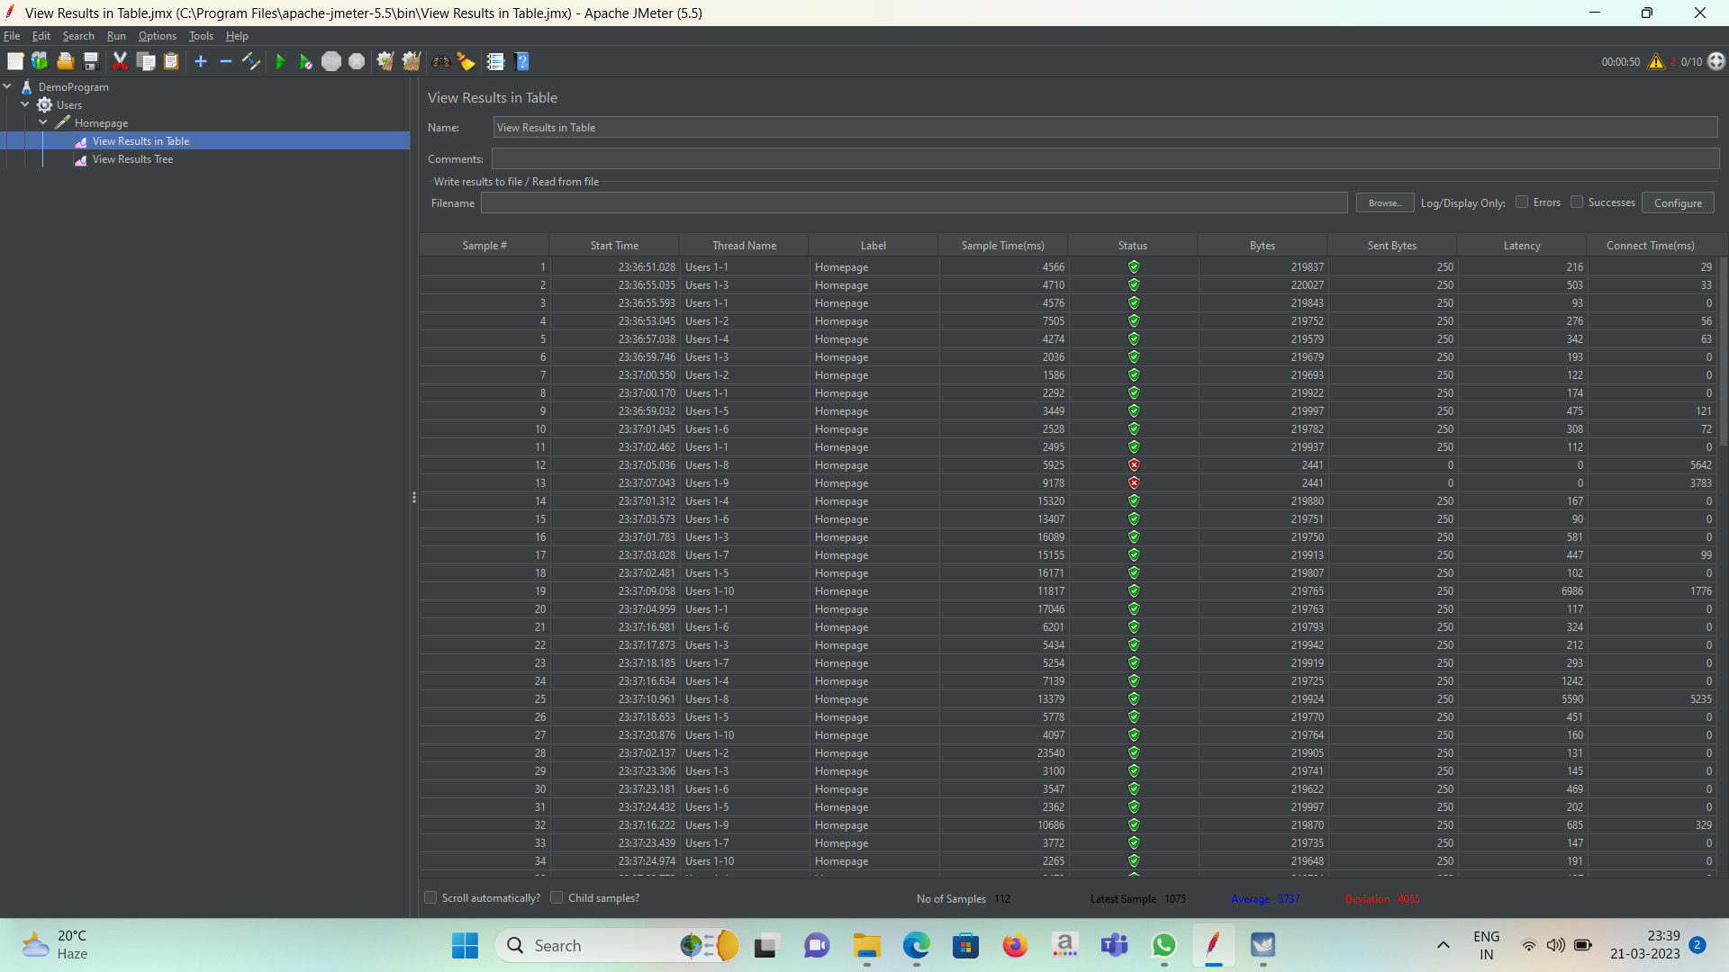

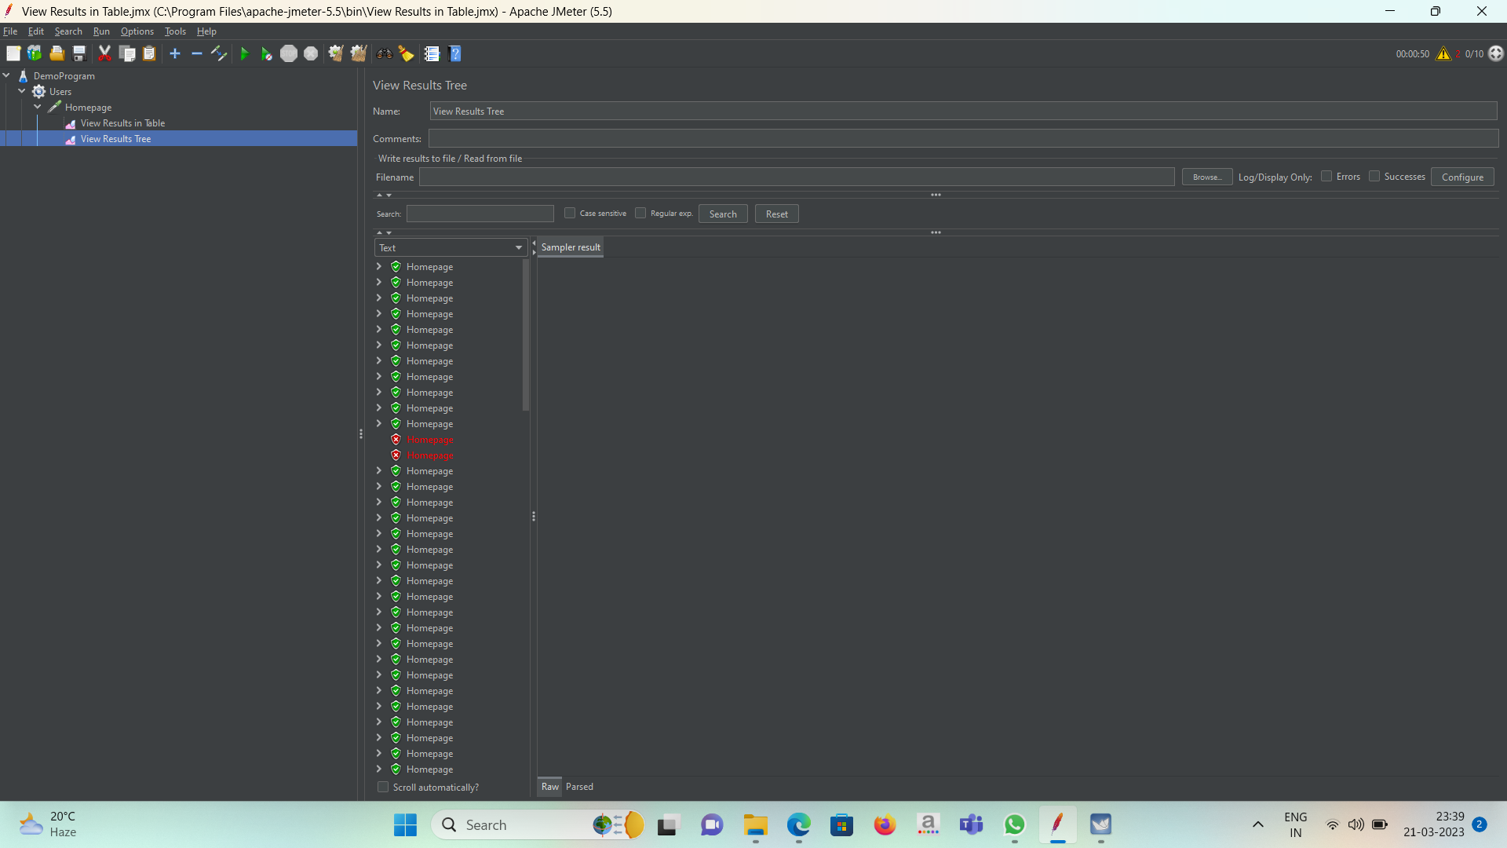

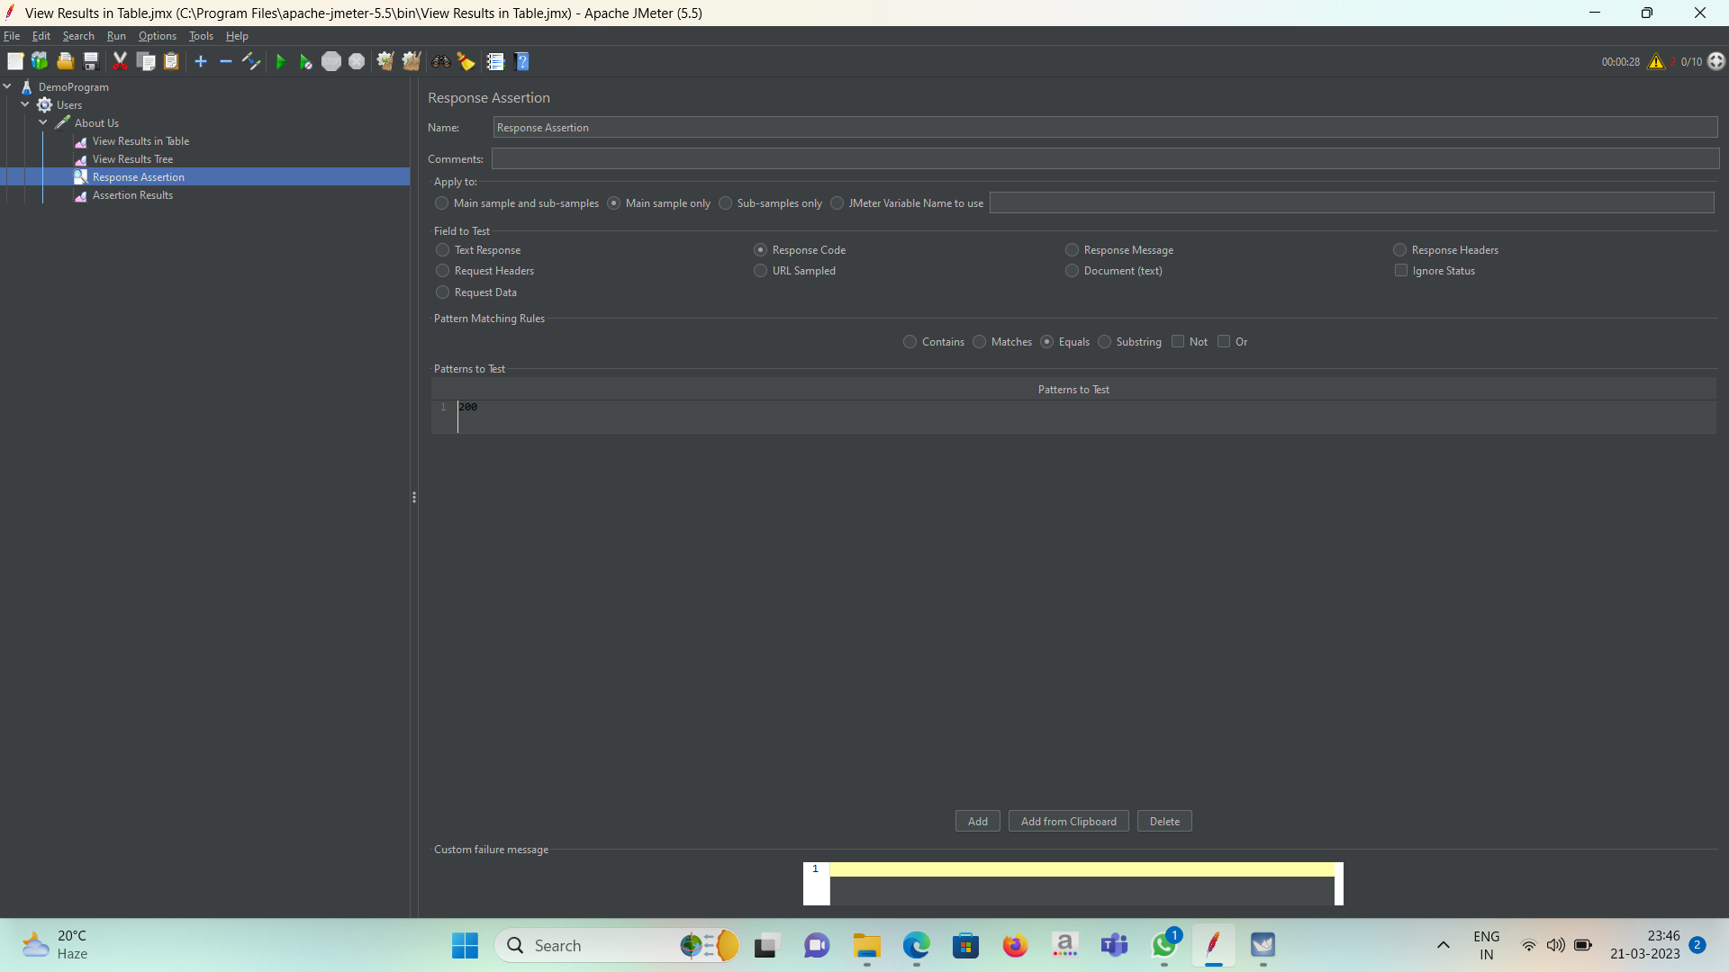

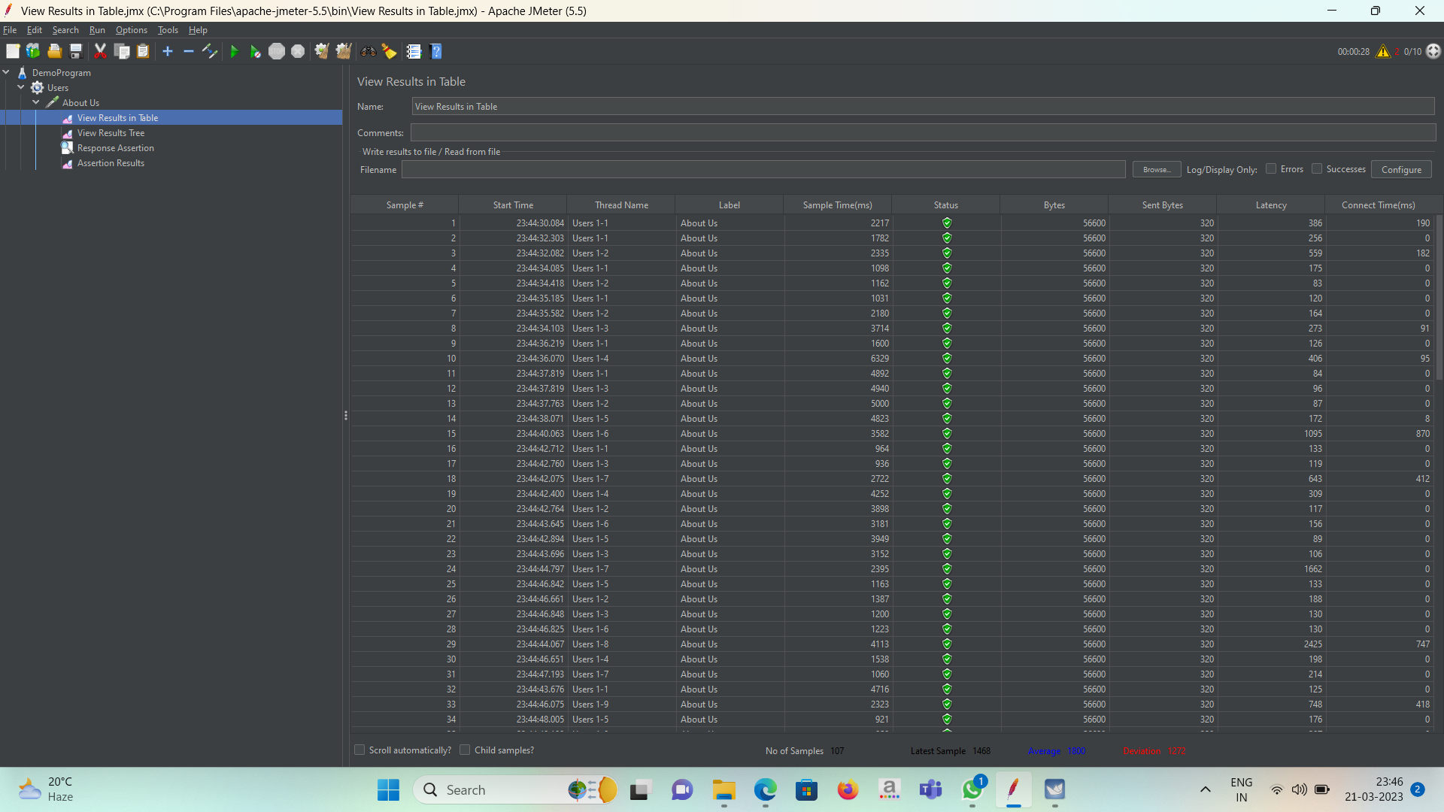

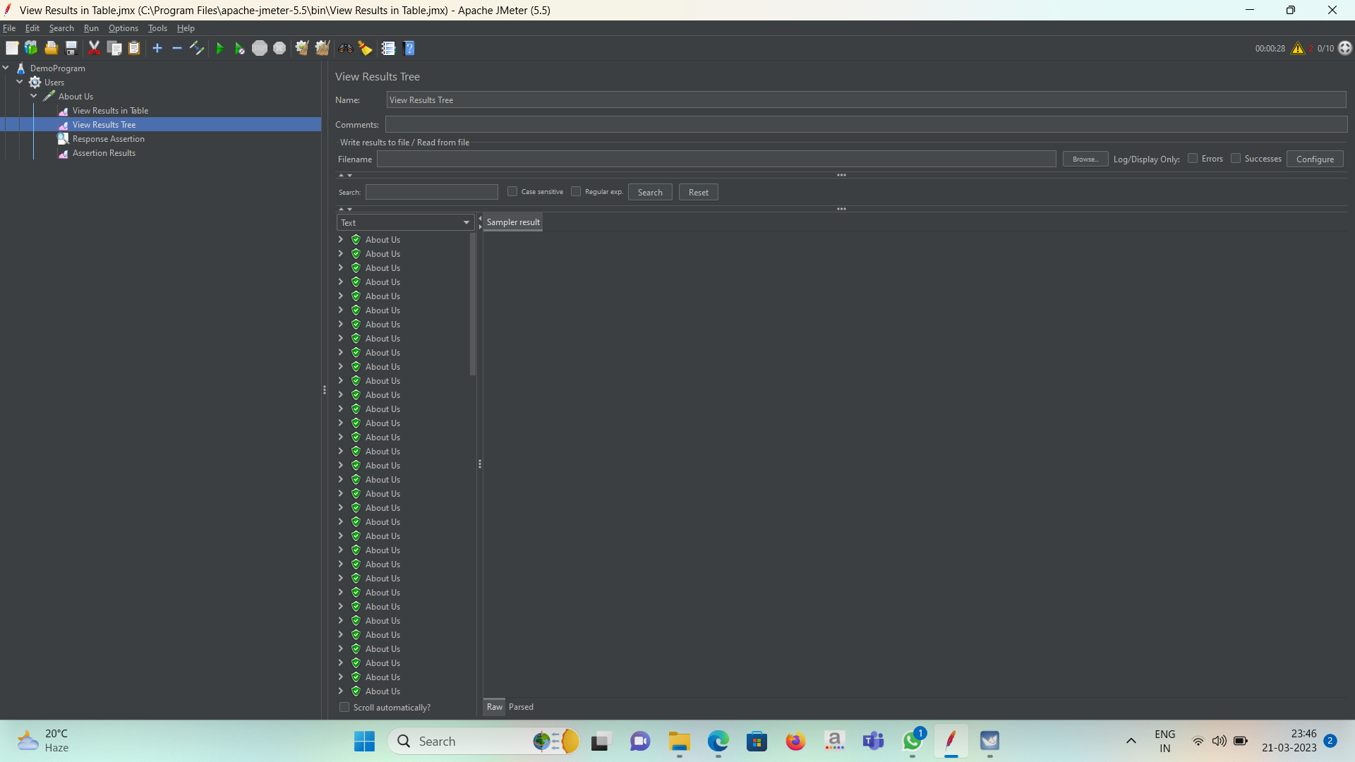

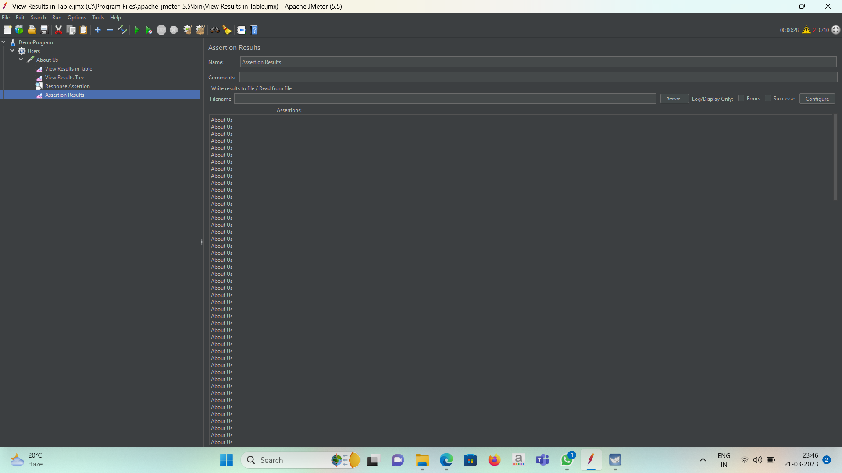

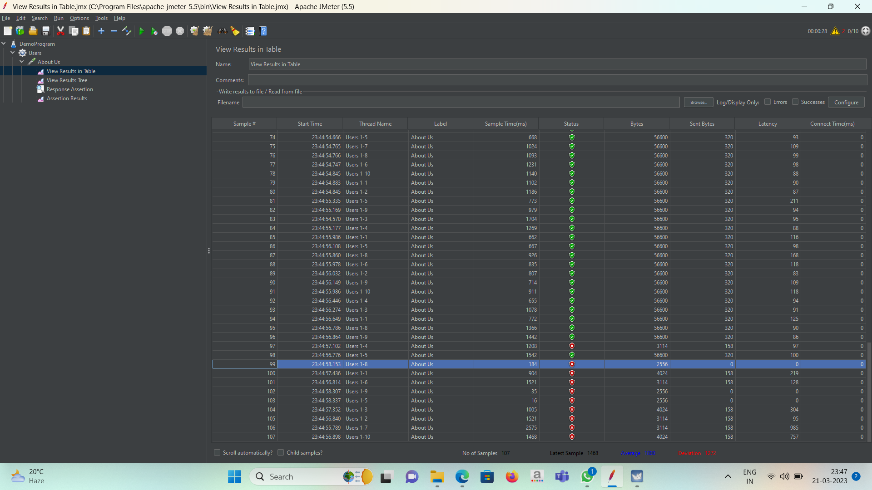

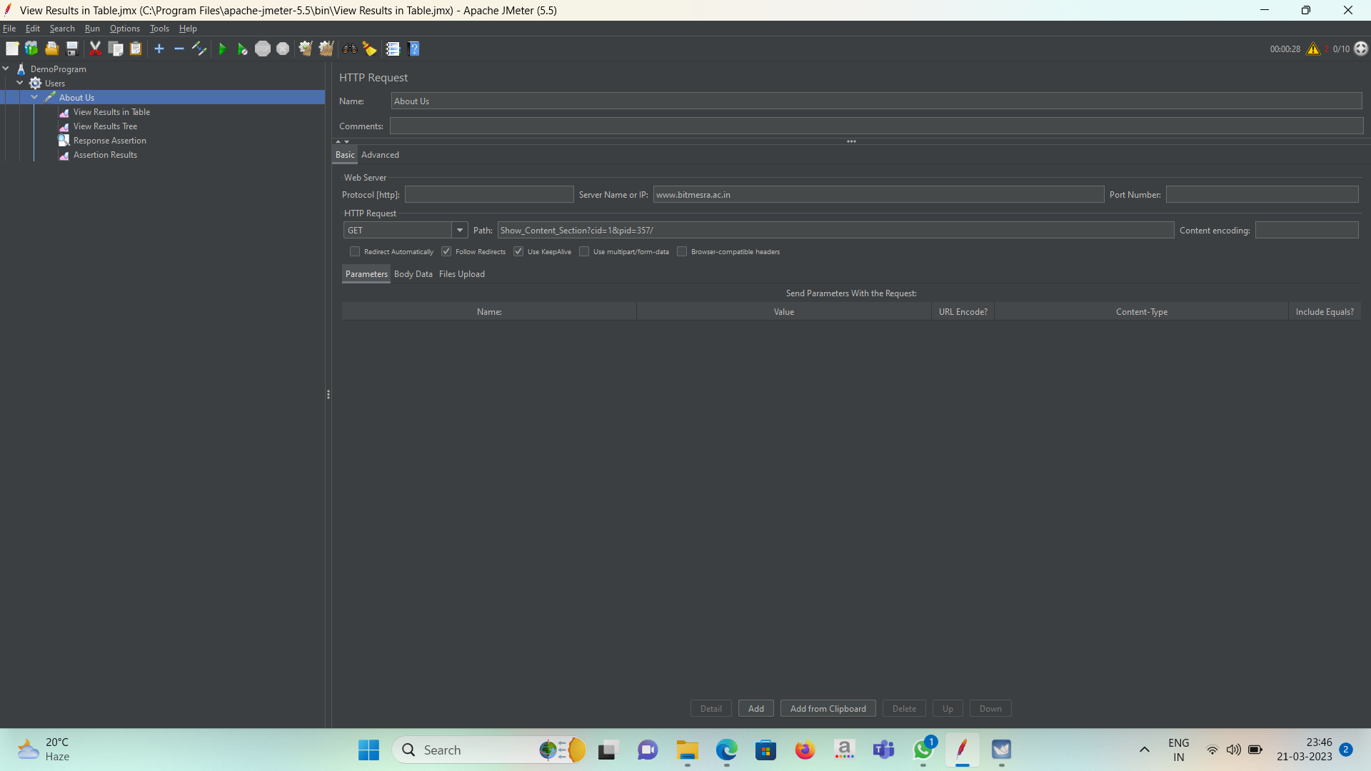

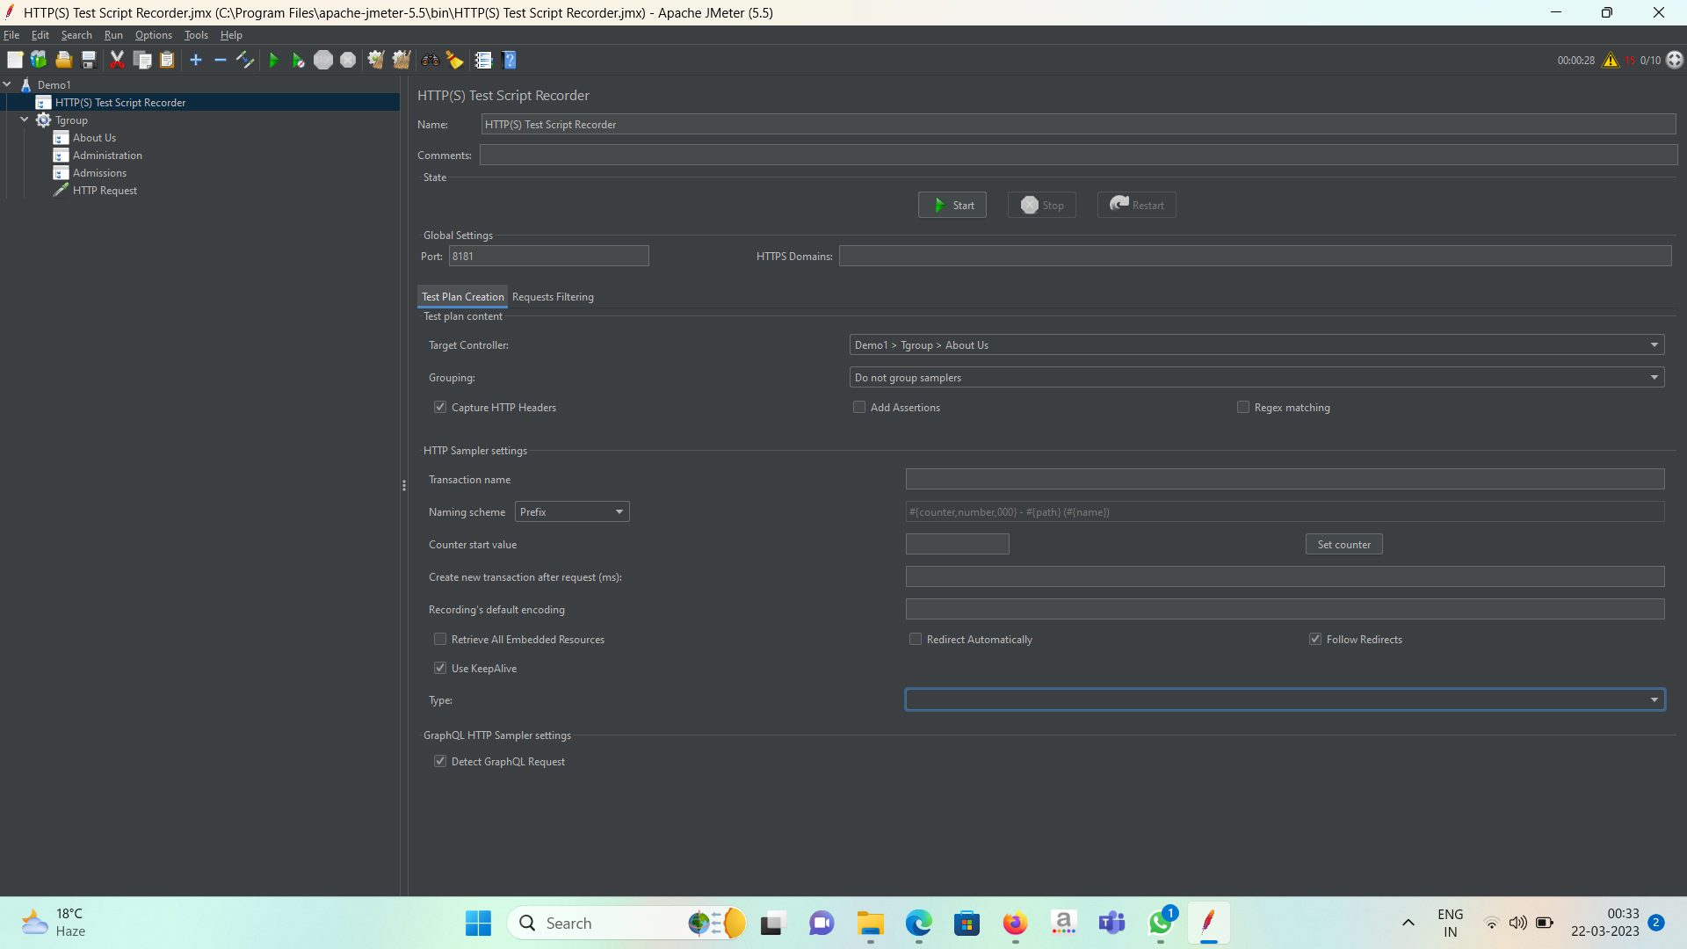

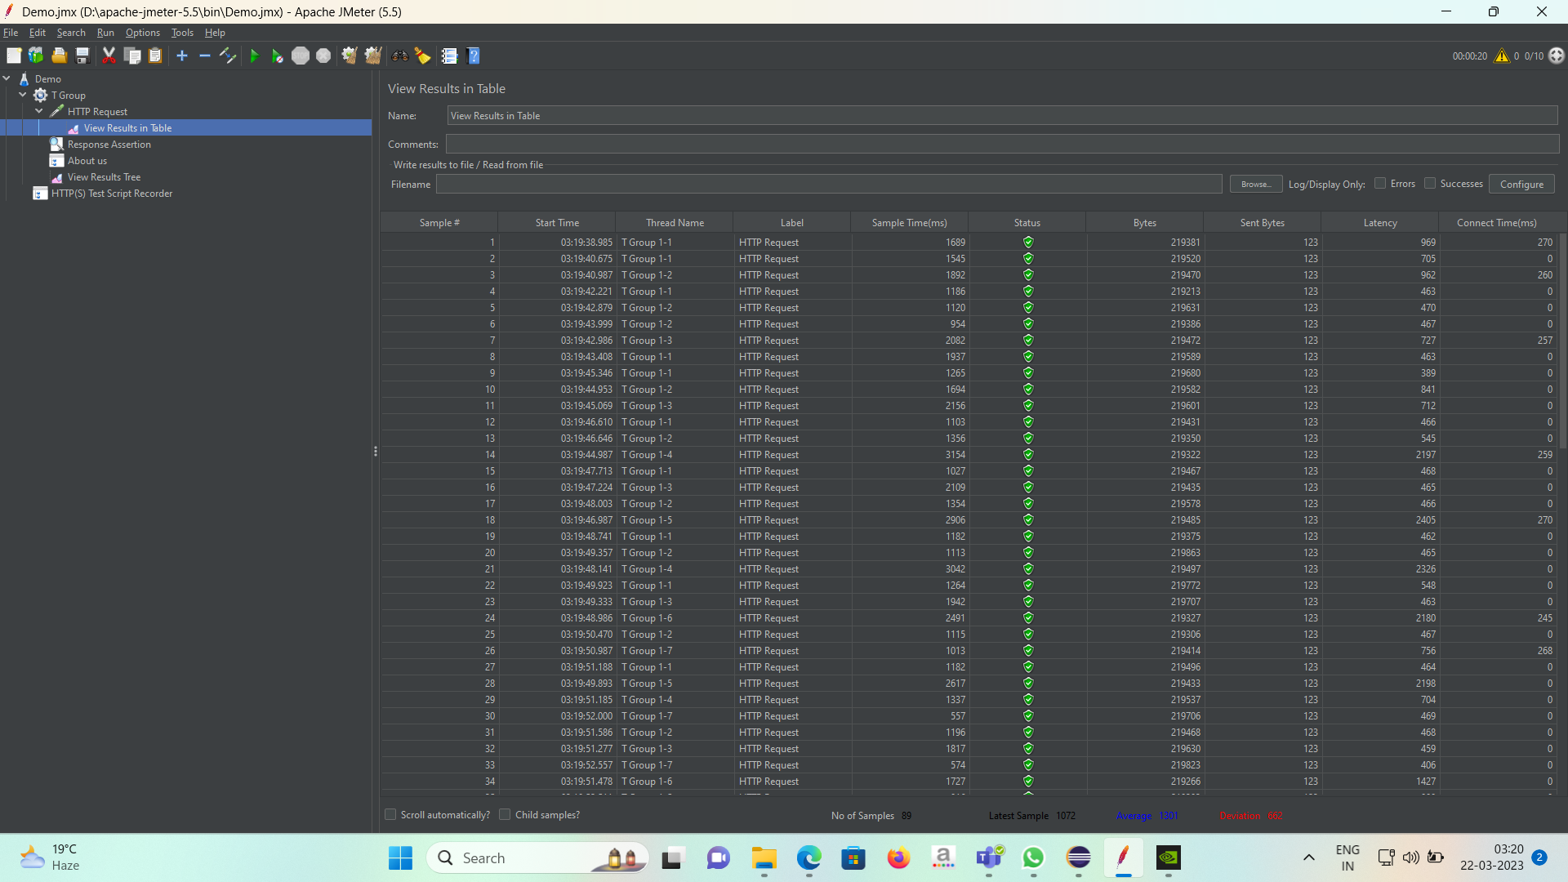

Maven + Junit:

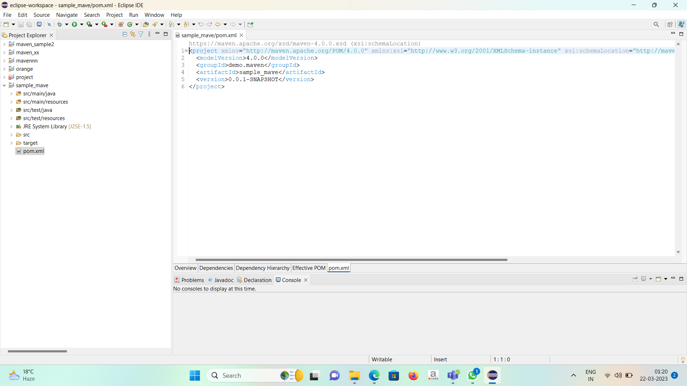

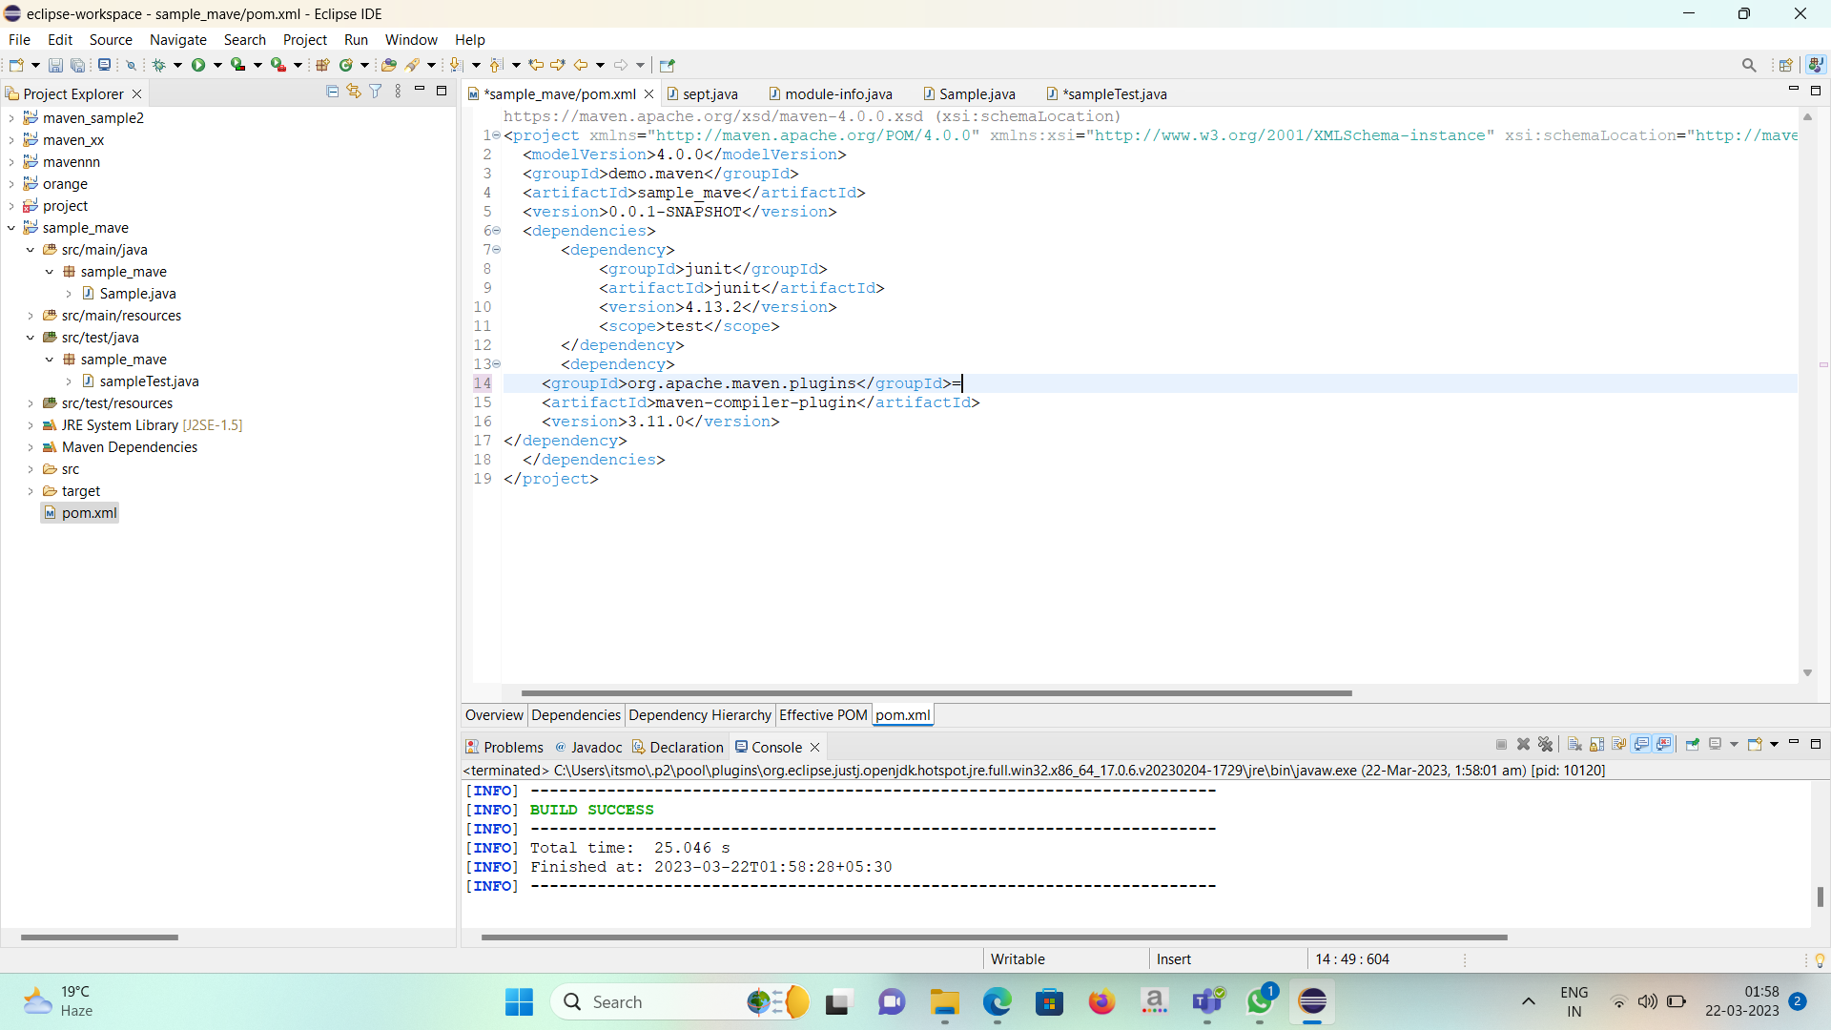

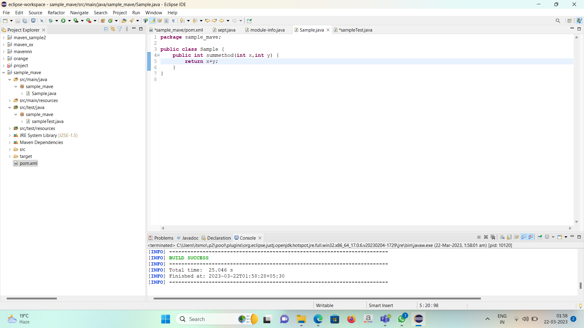

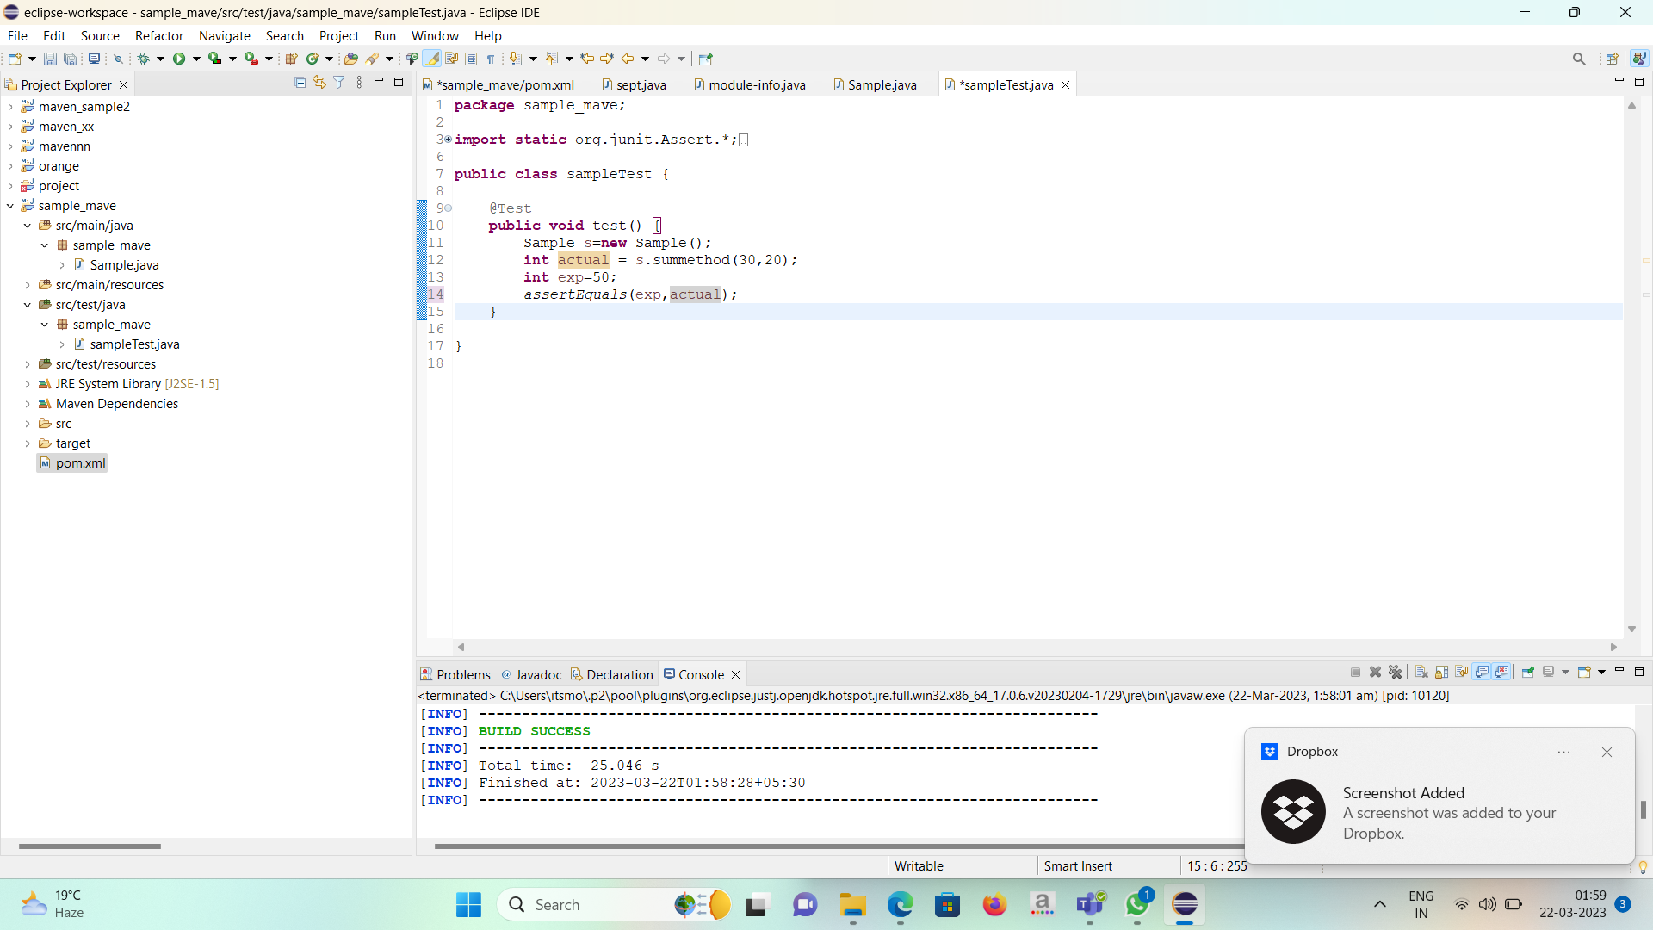

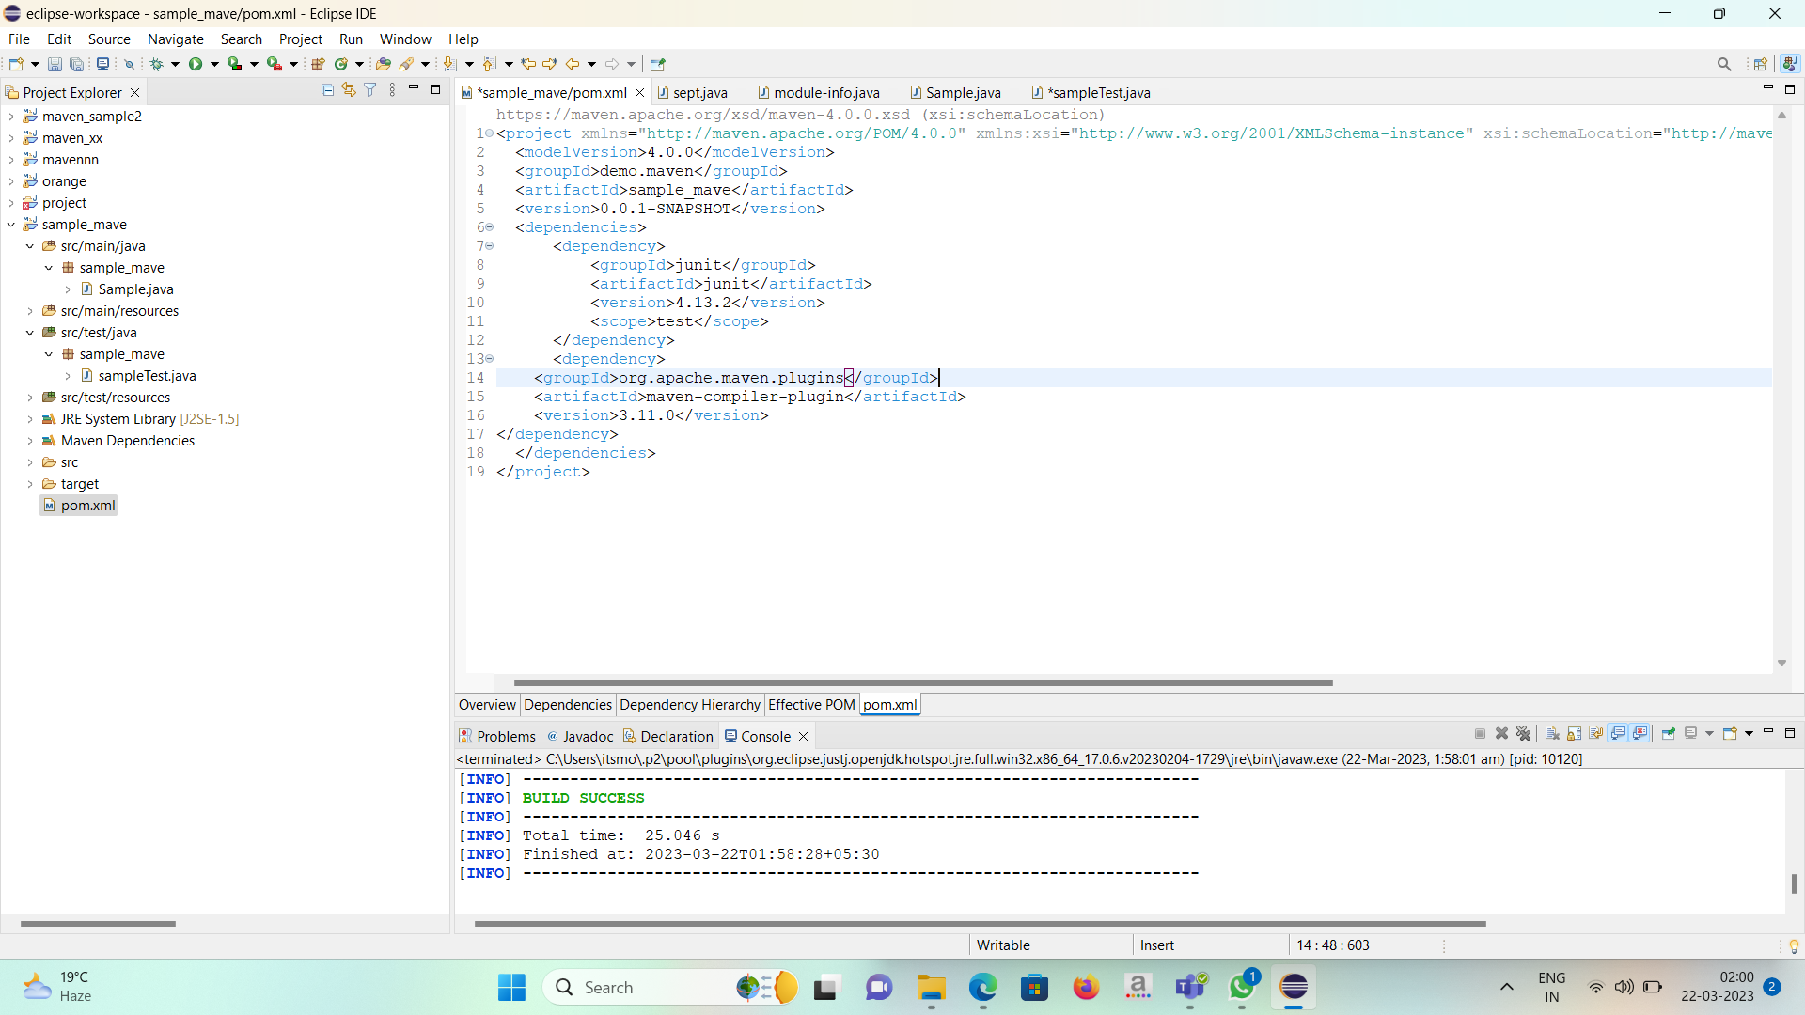

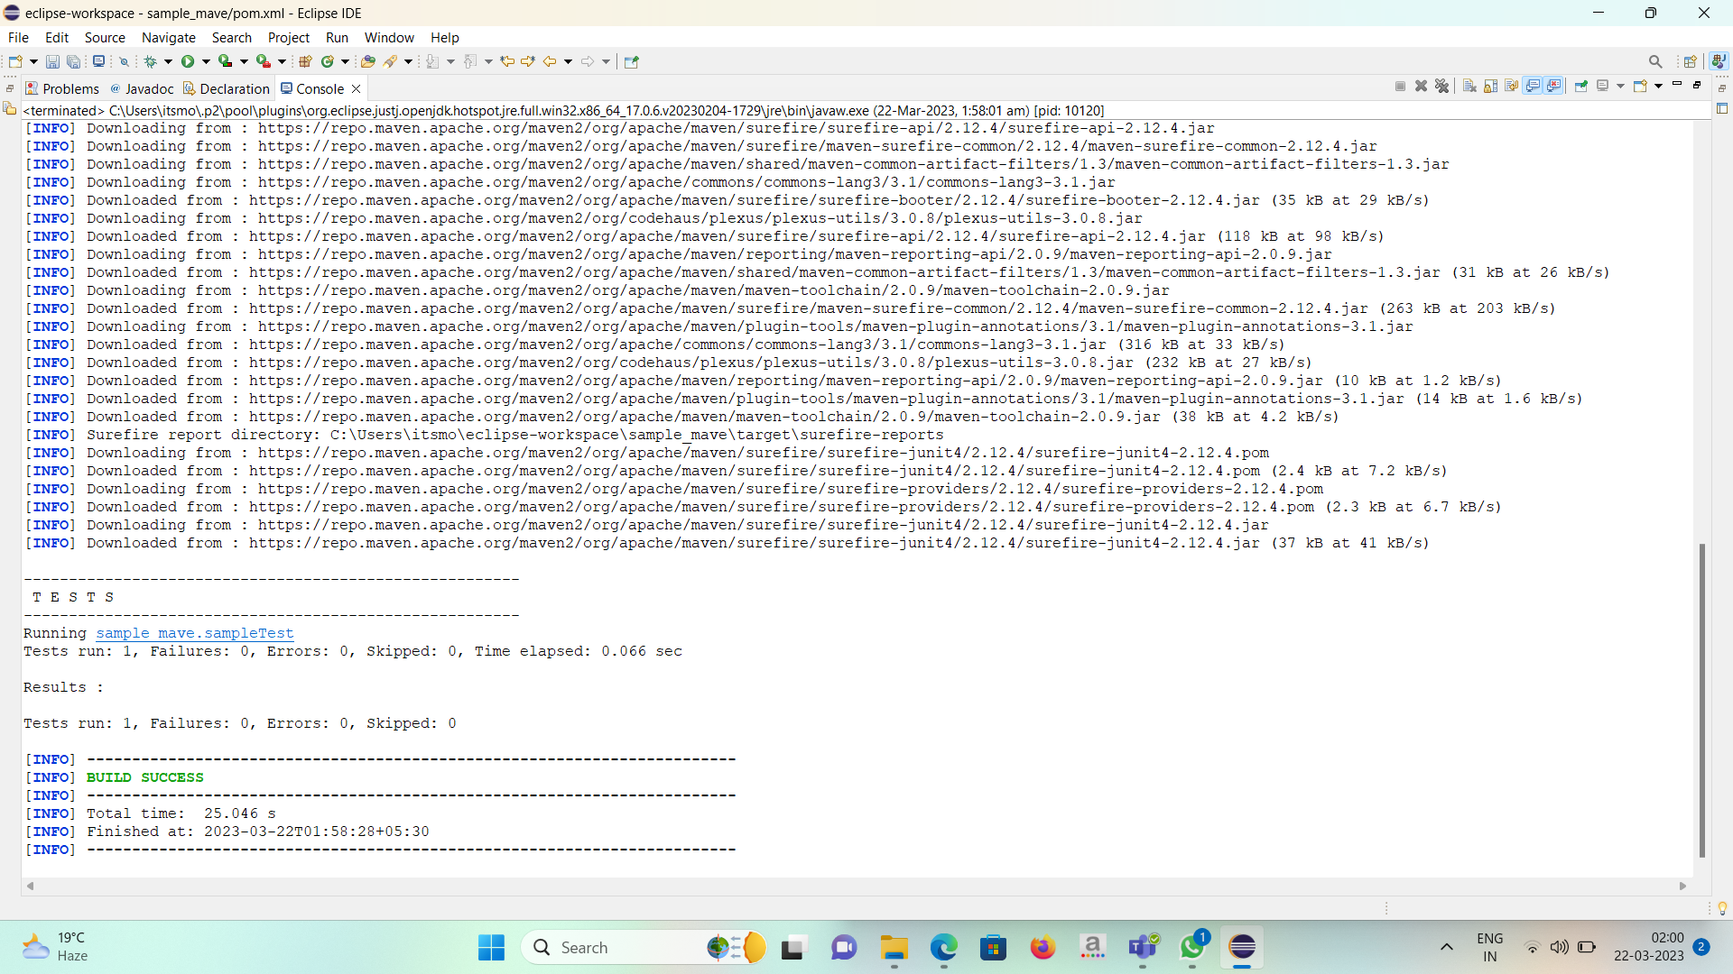

Cucumber + TestNg:

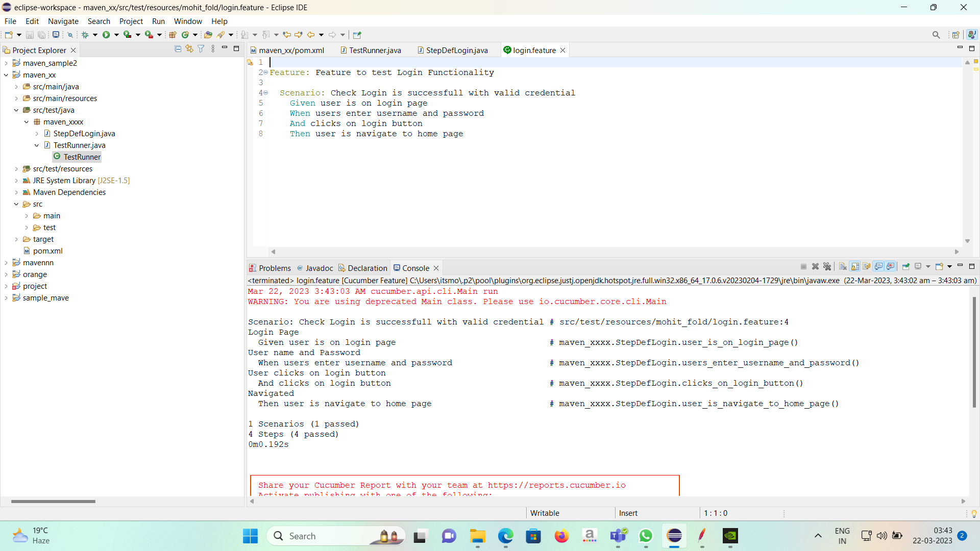

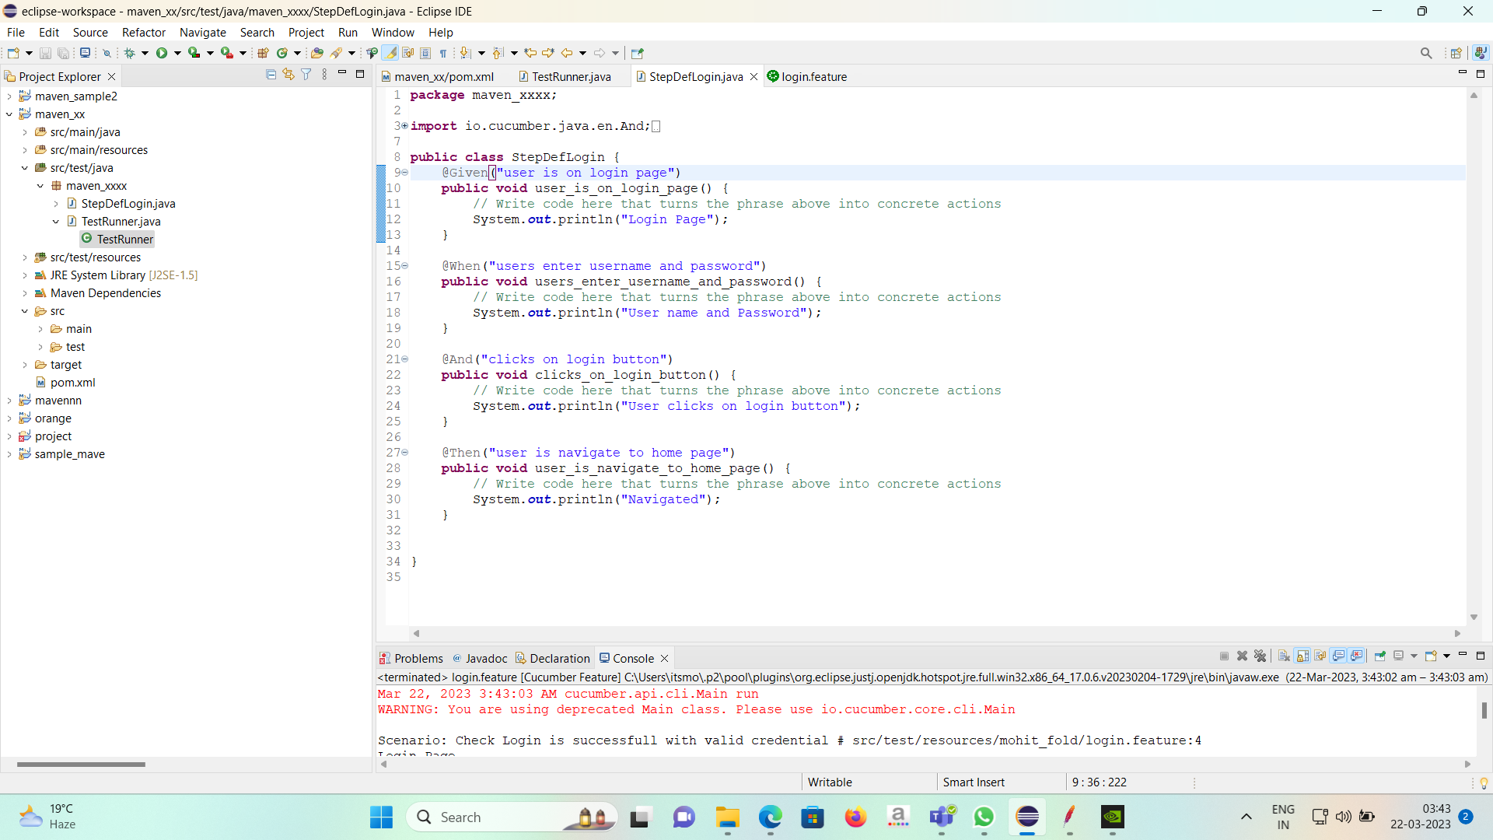

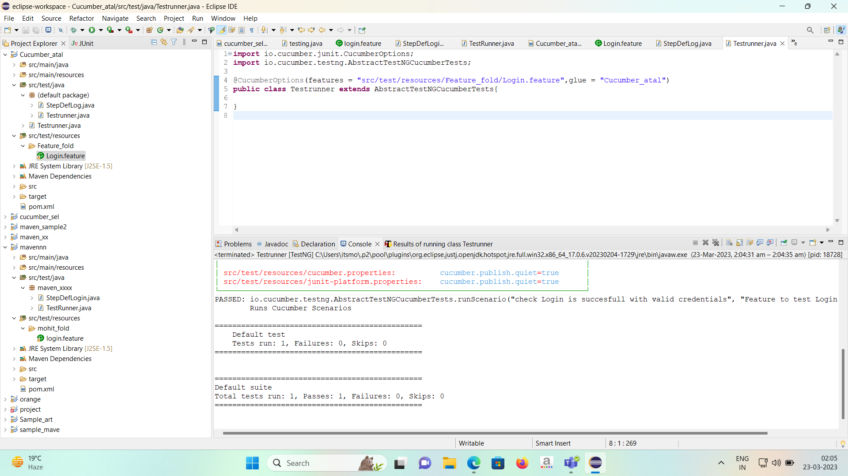

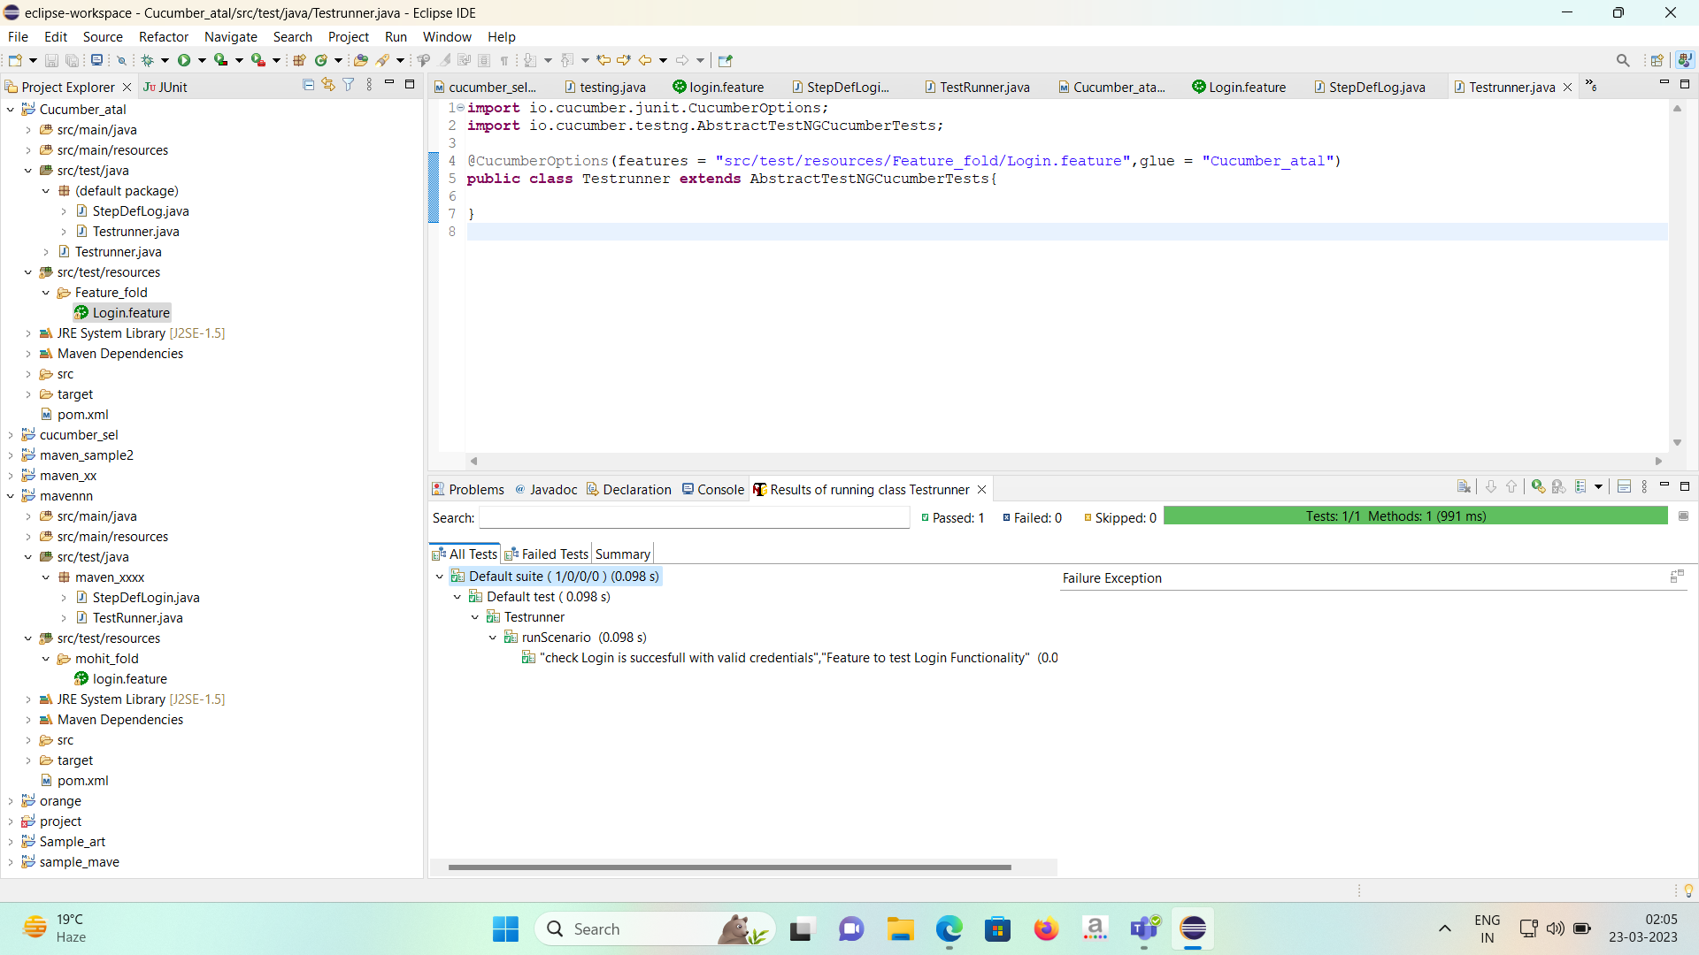

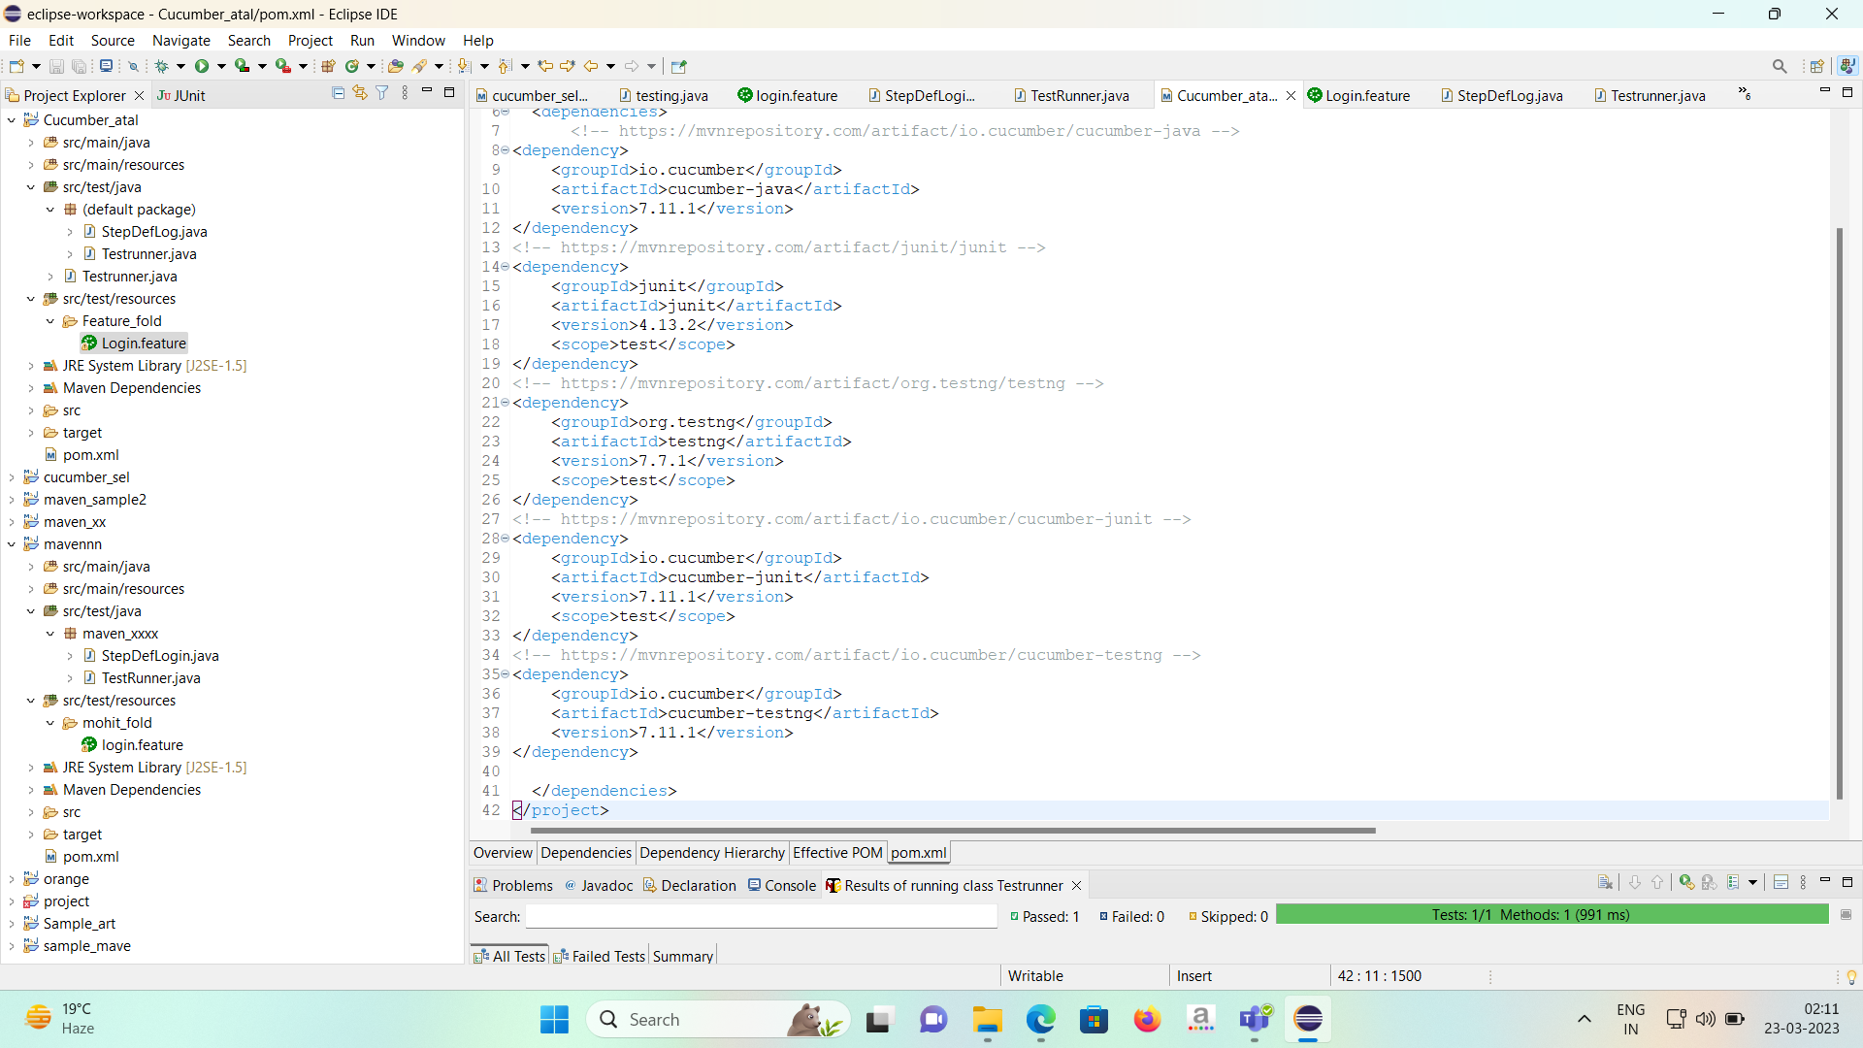

Selenium:

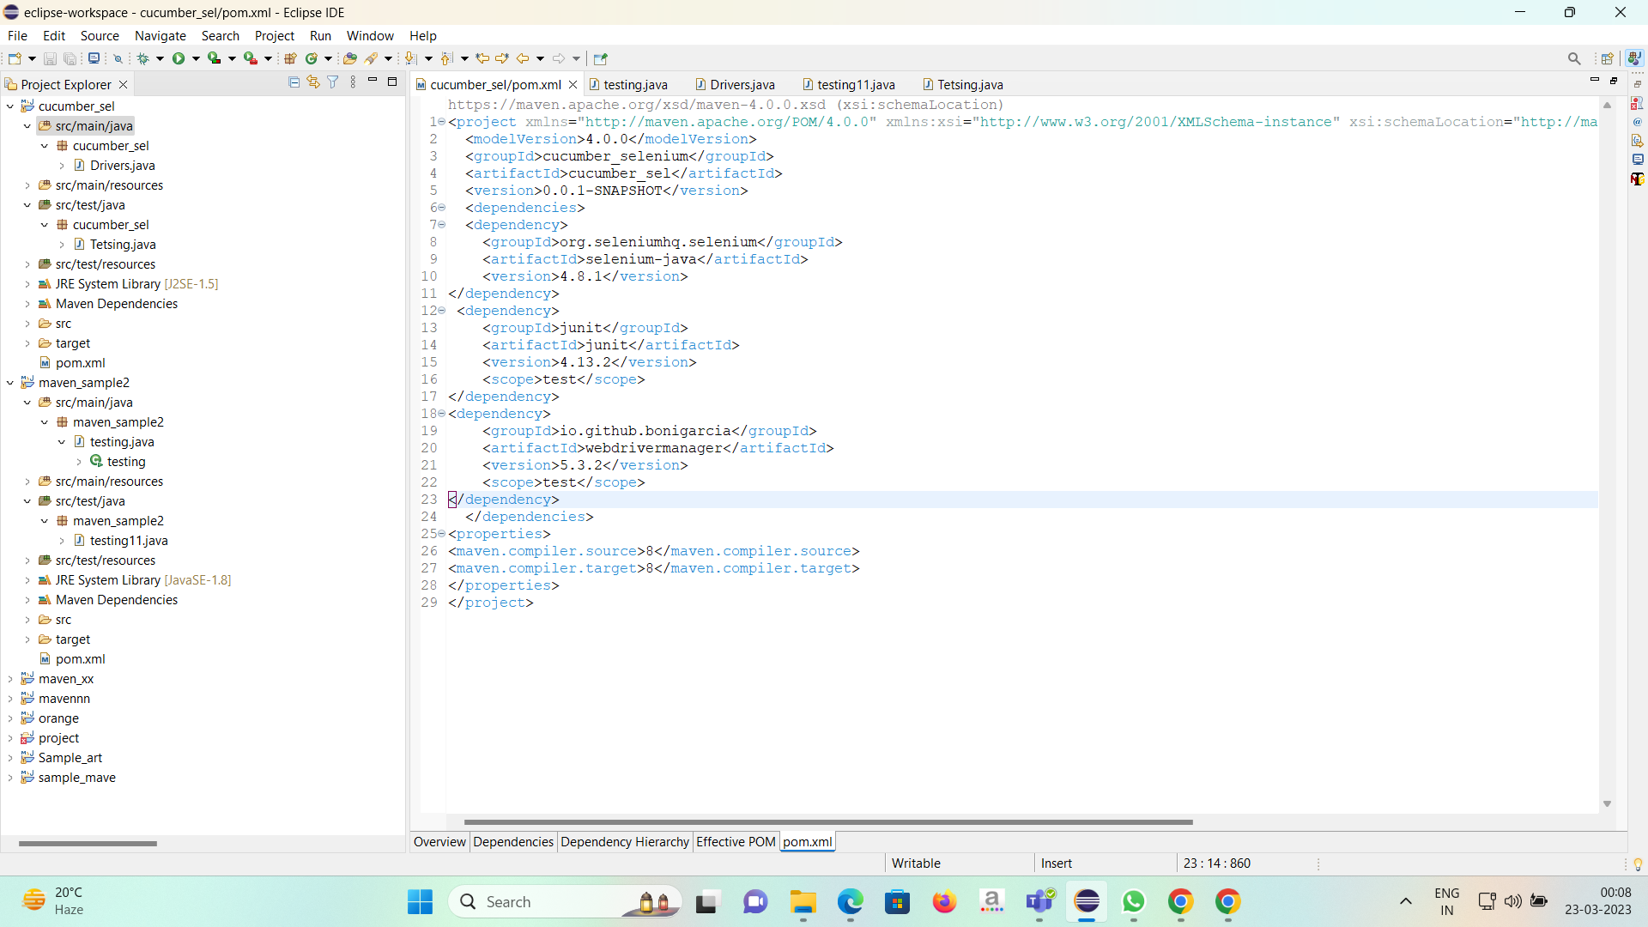

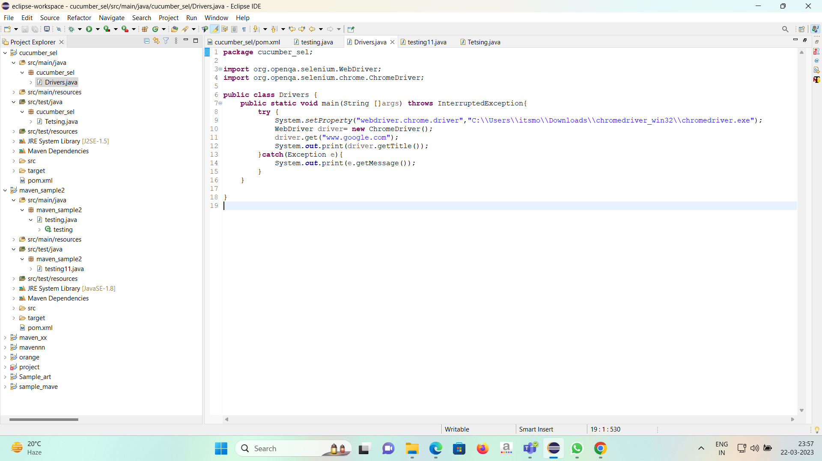

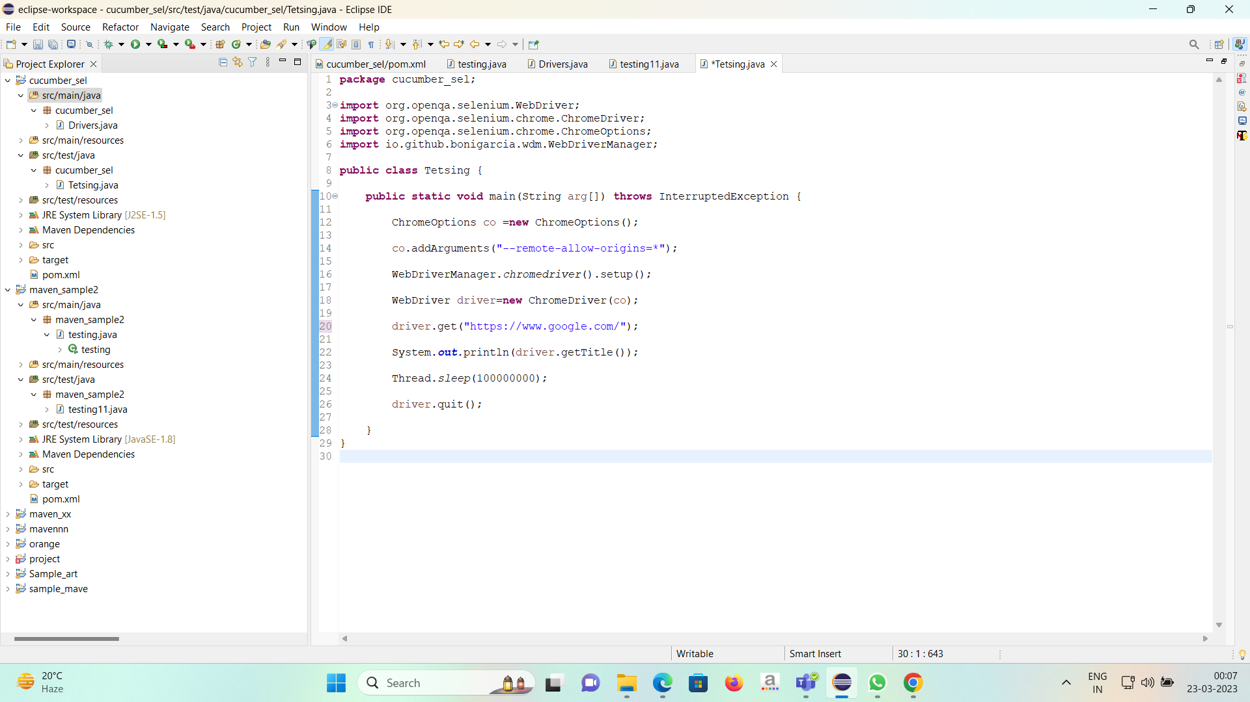

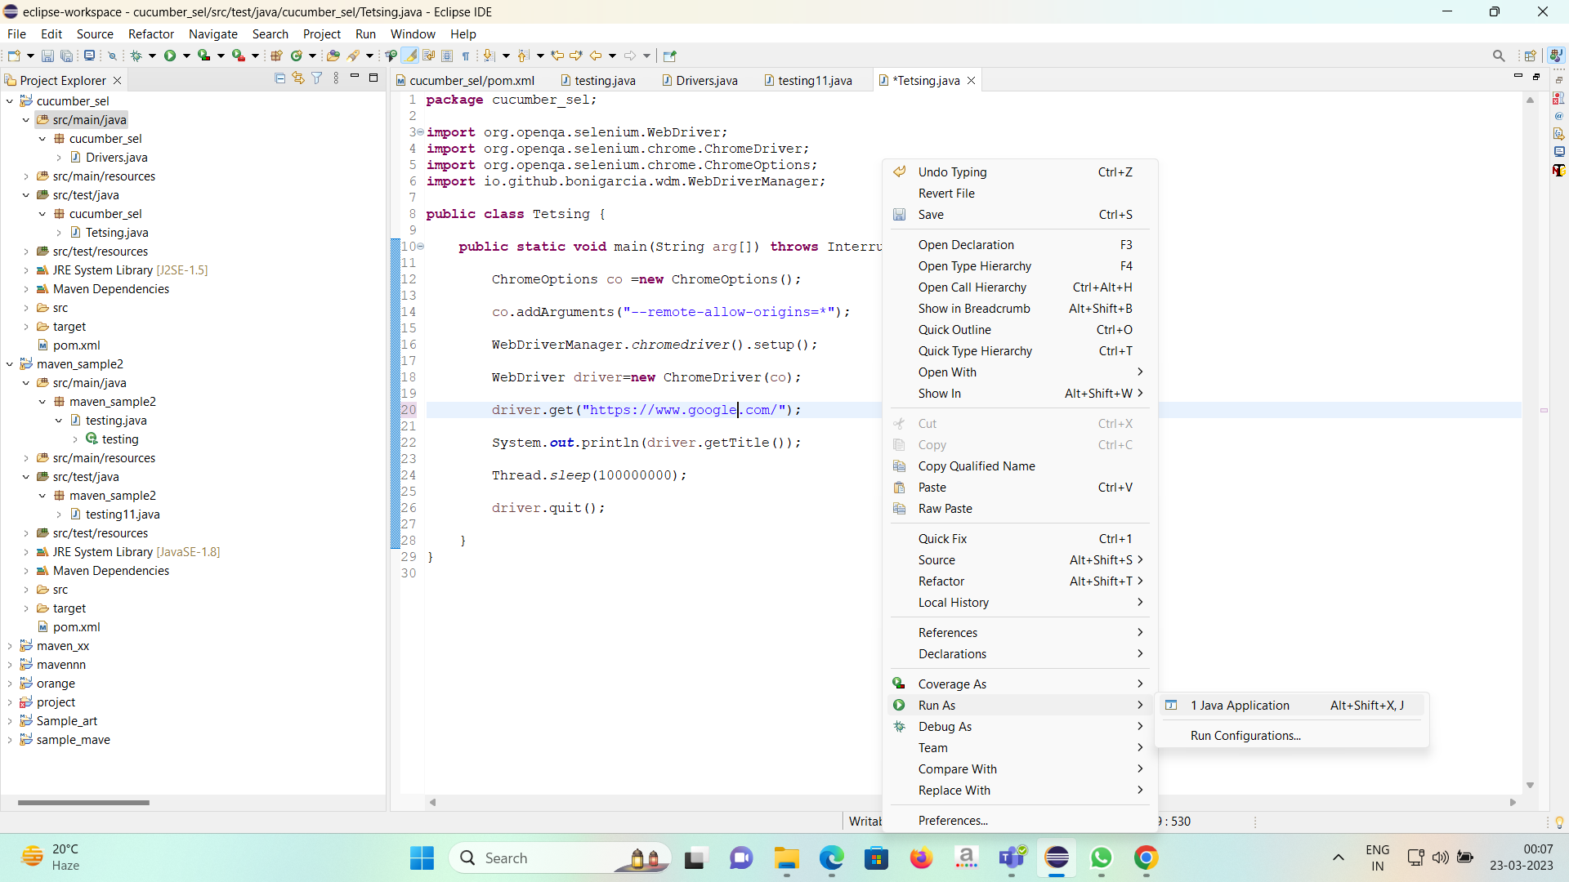

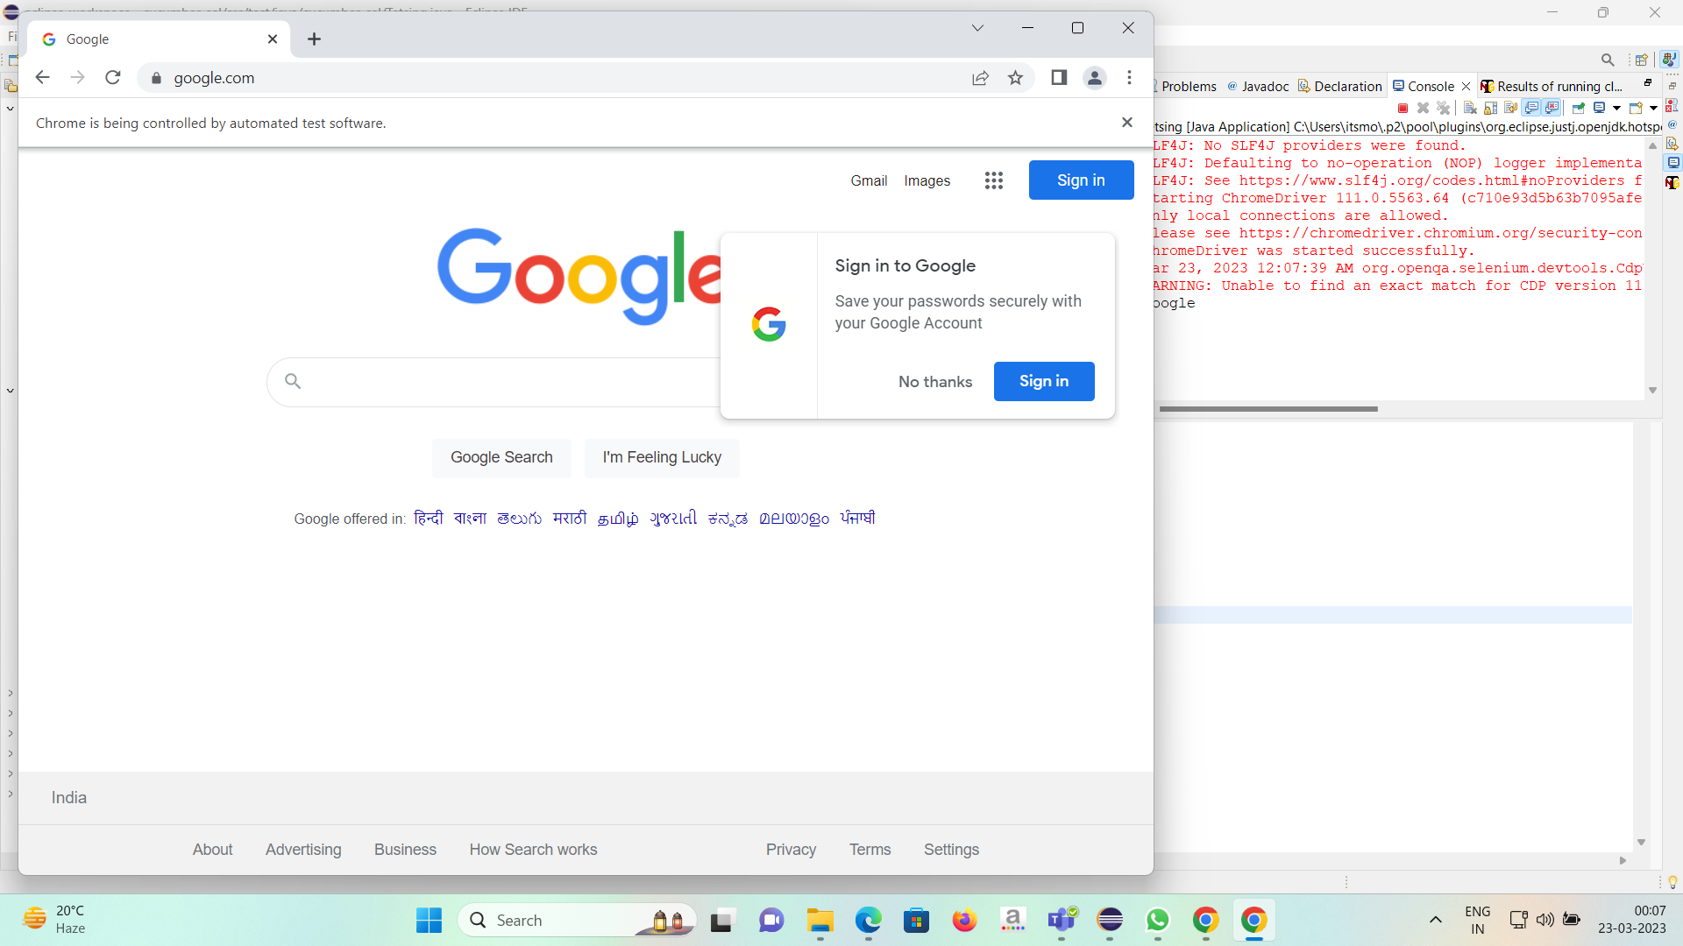

**Lab Assignment No. 9)Prototype development(10)**

**Solution:**

Prototype of Hospital management System is programmed using java and to provide UI I here have used JOptionpane.

When we run our code the first page that pops up is: -

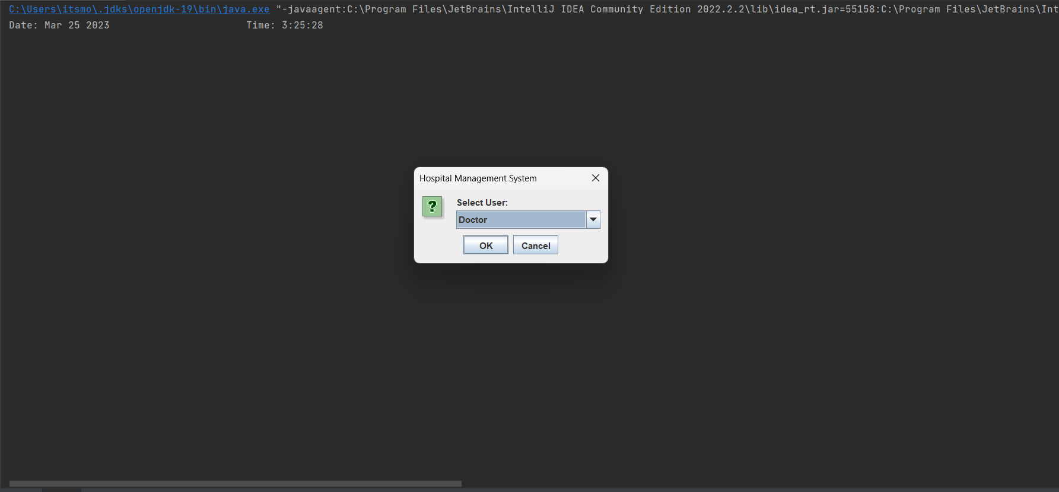

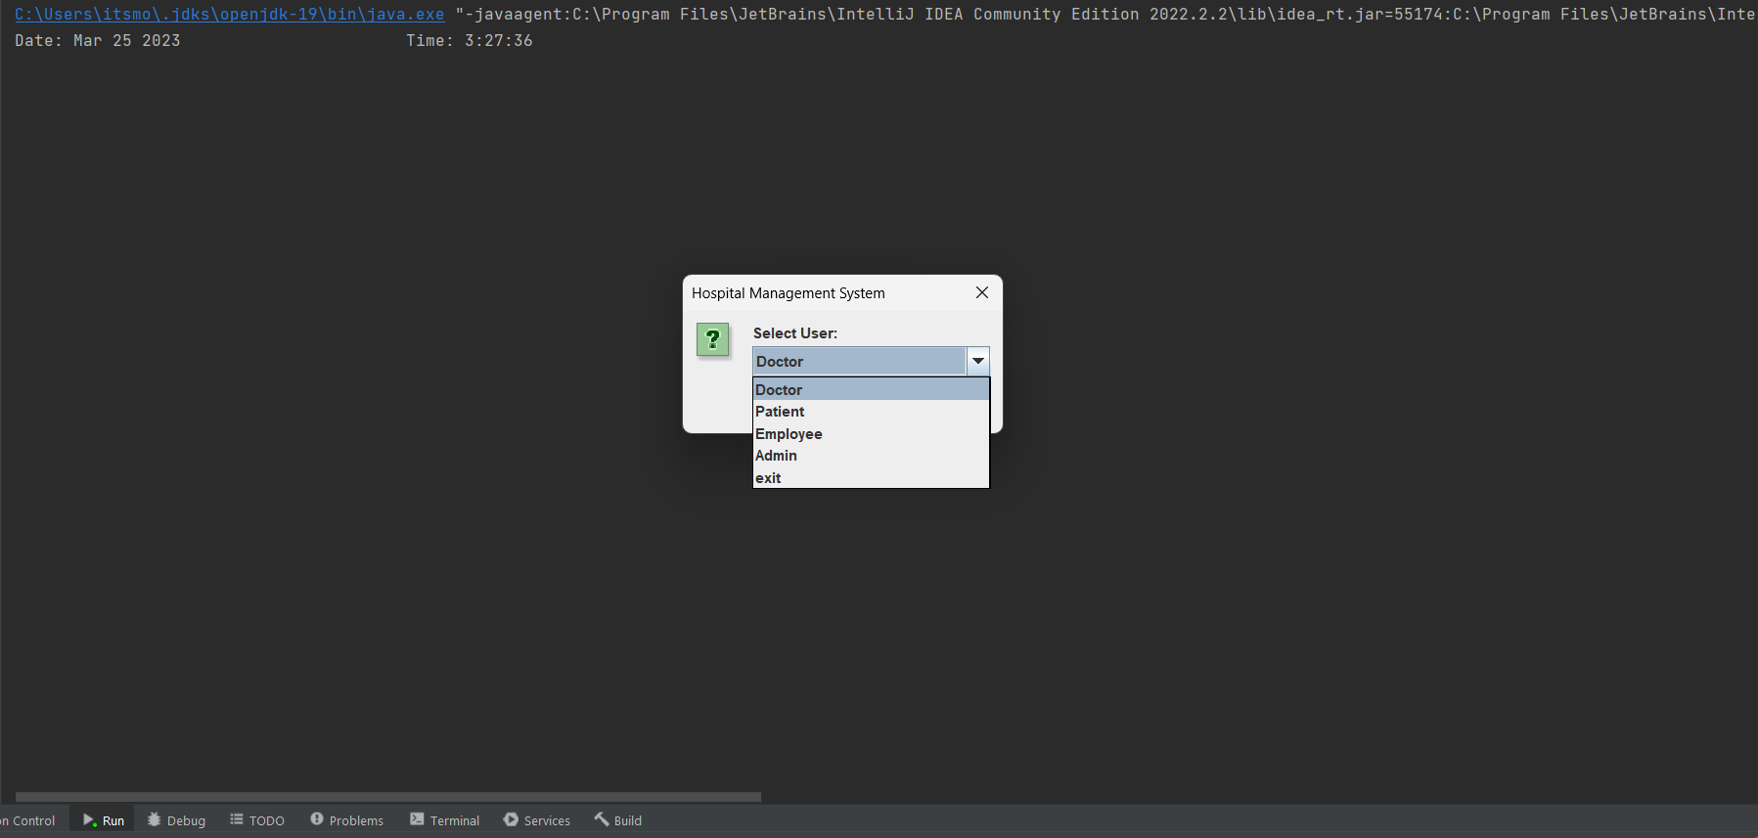

After selecting a user which in this case is Doctor we have to give user name and password of the user logging In and if the credentials are correct user gets success message if not then invalid id and password : -

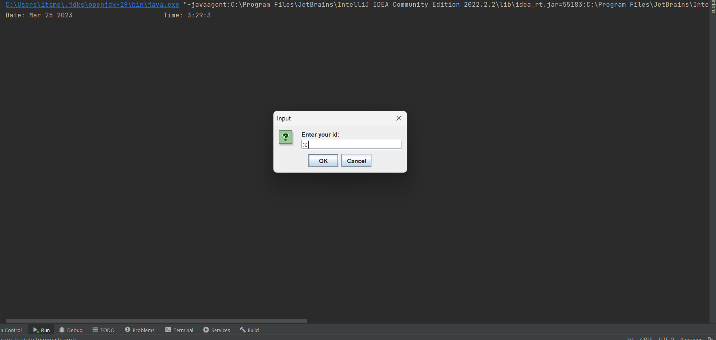

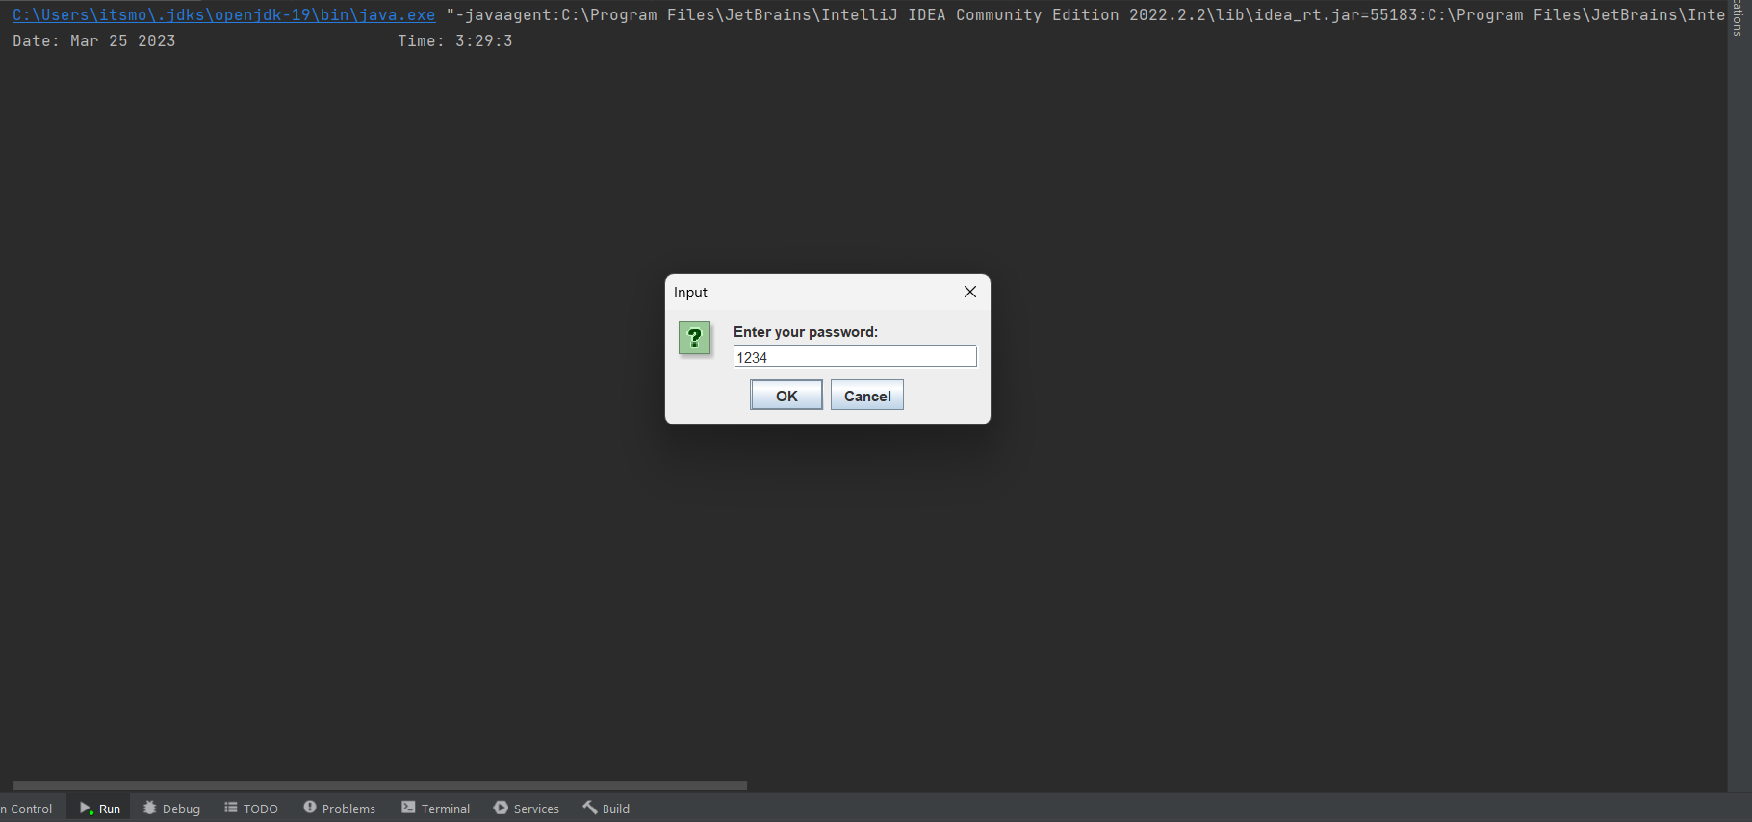

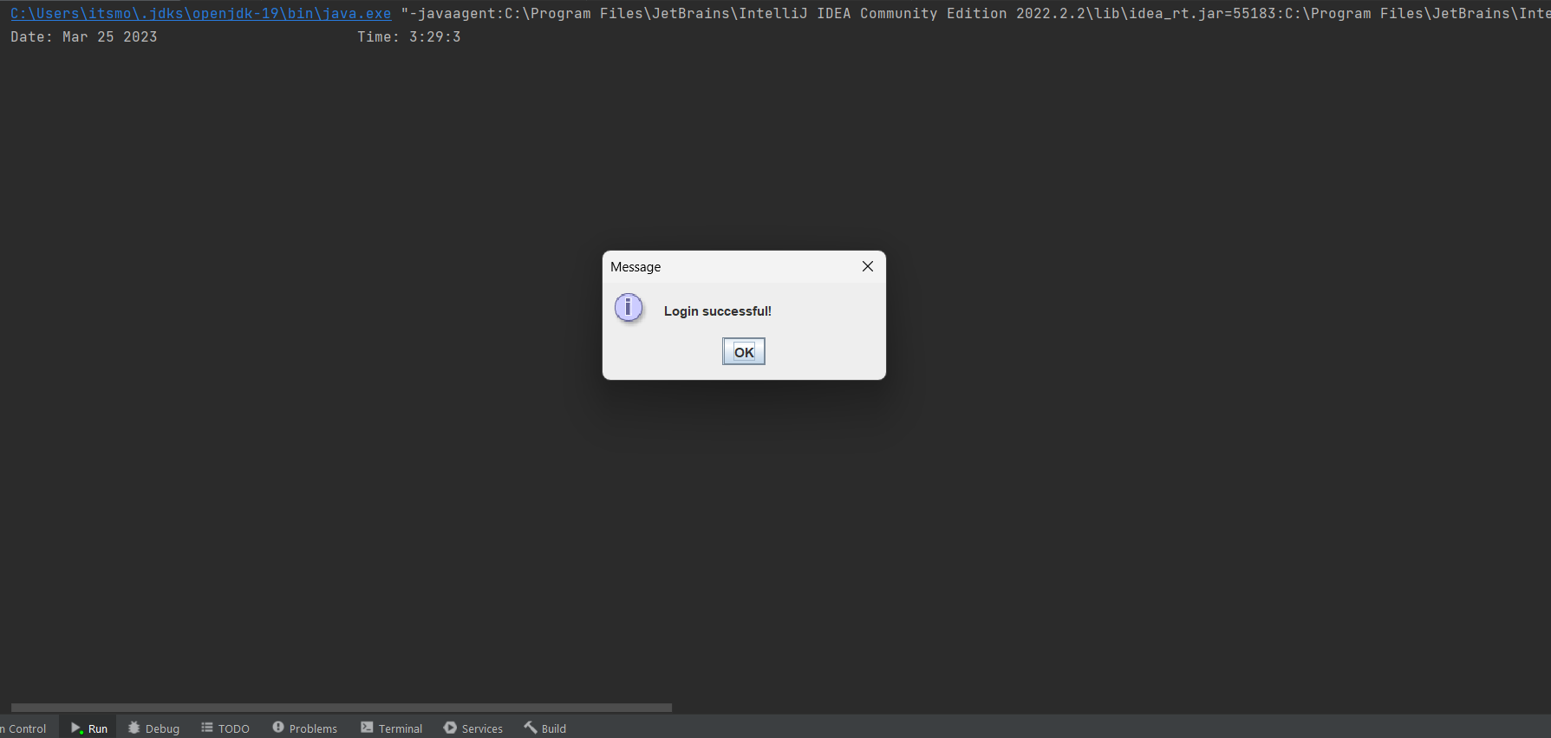

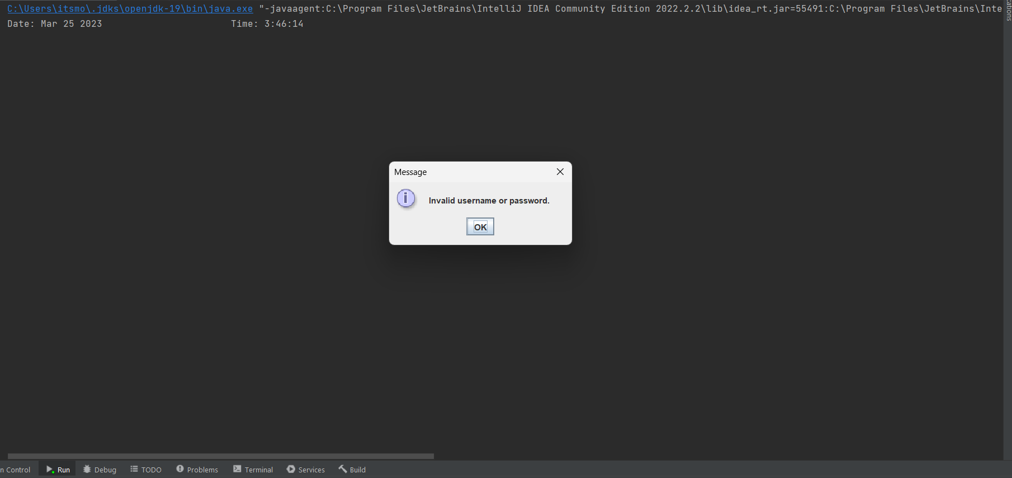

If Login Successful then more options can be selected from selection bar like details of (patient, doctors, employee, medicine, labs) by choosing them we can get the details :-

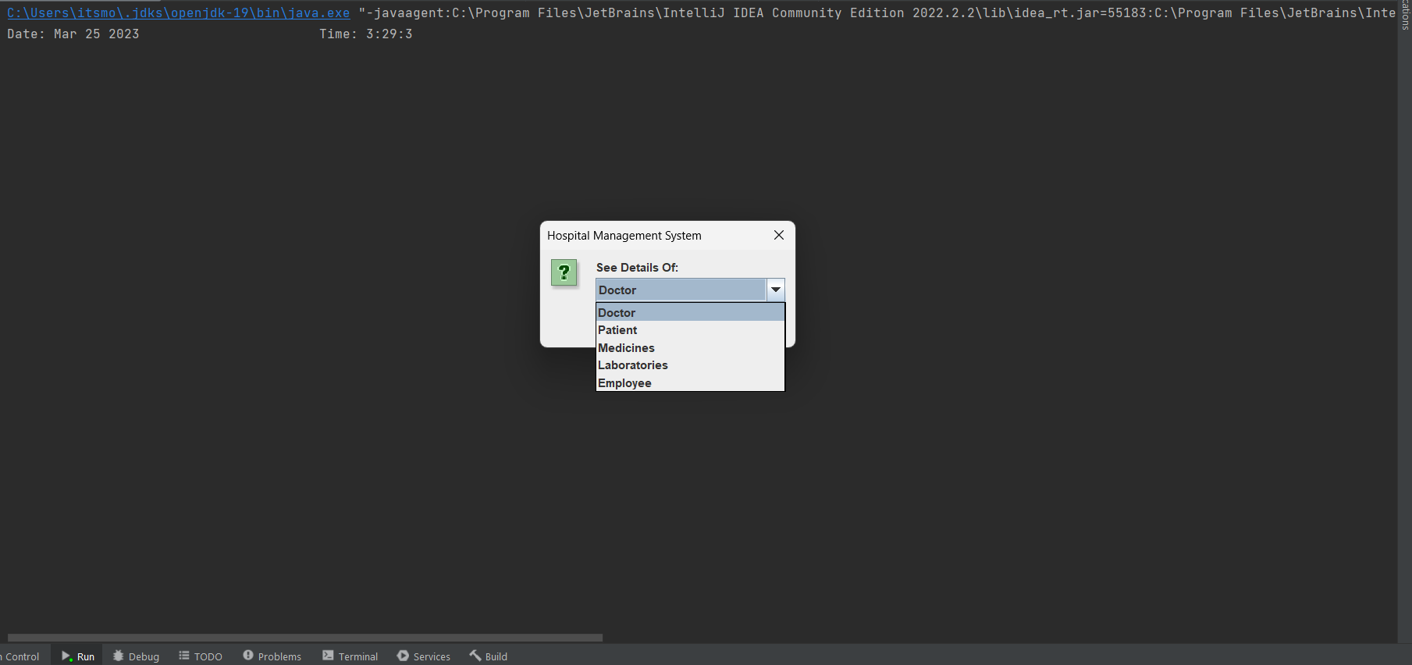

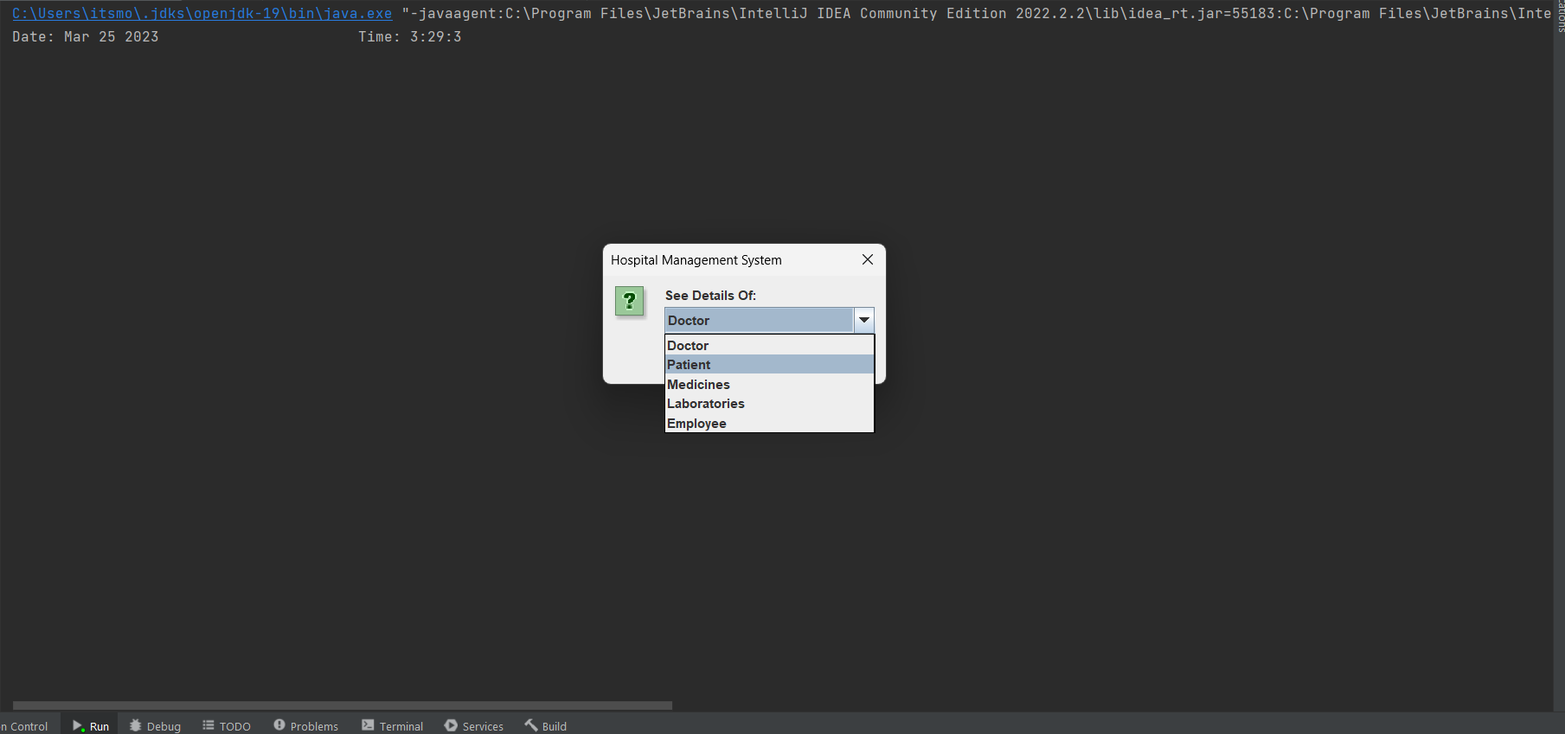

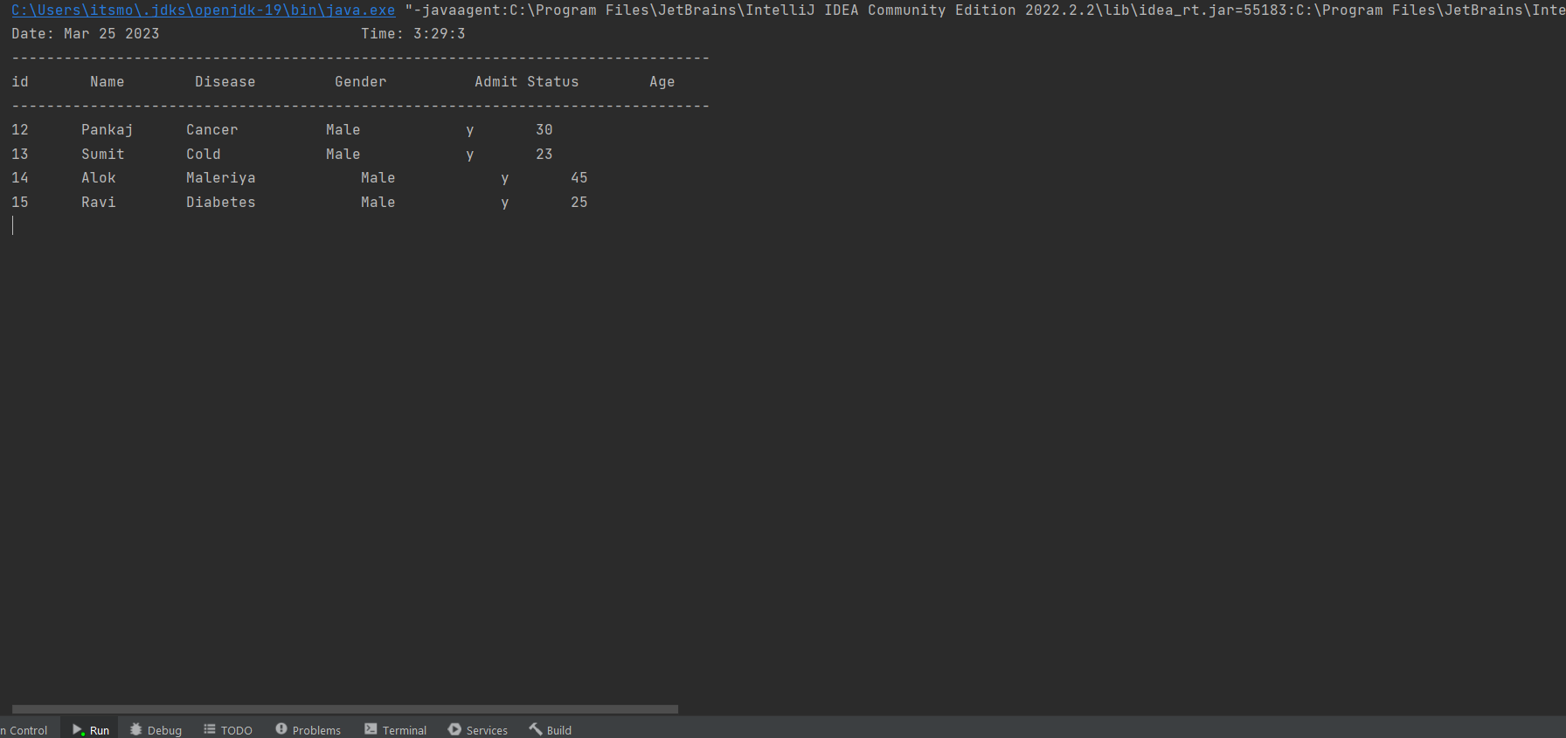

After getting the details we will then get buttons to go pack to previous options or to the main menu: -

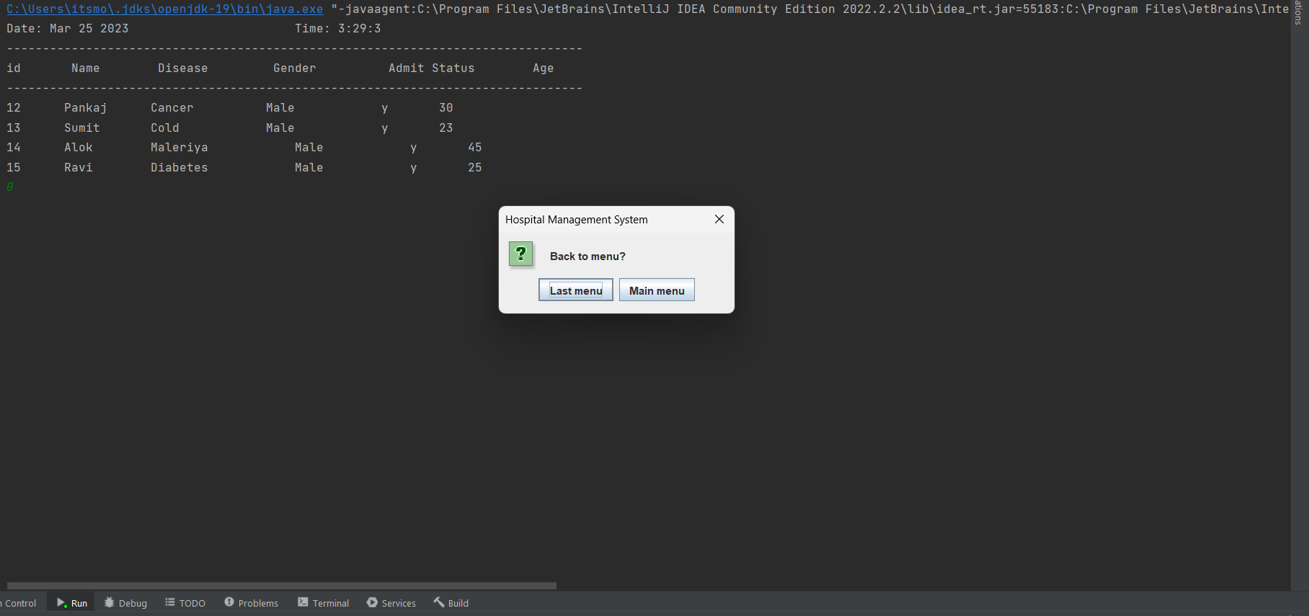

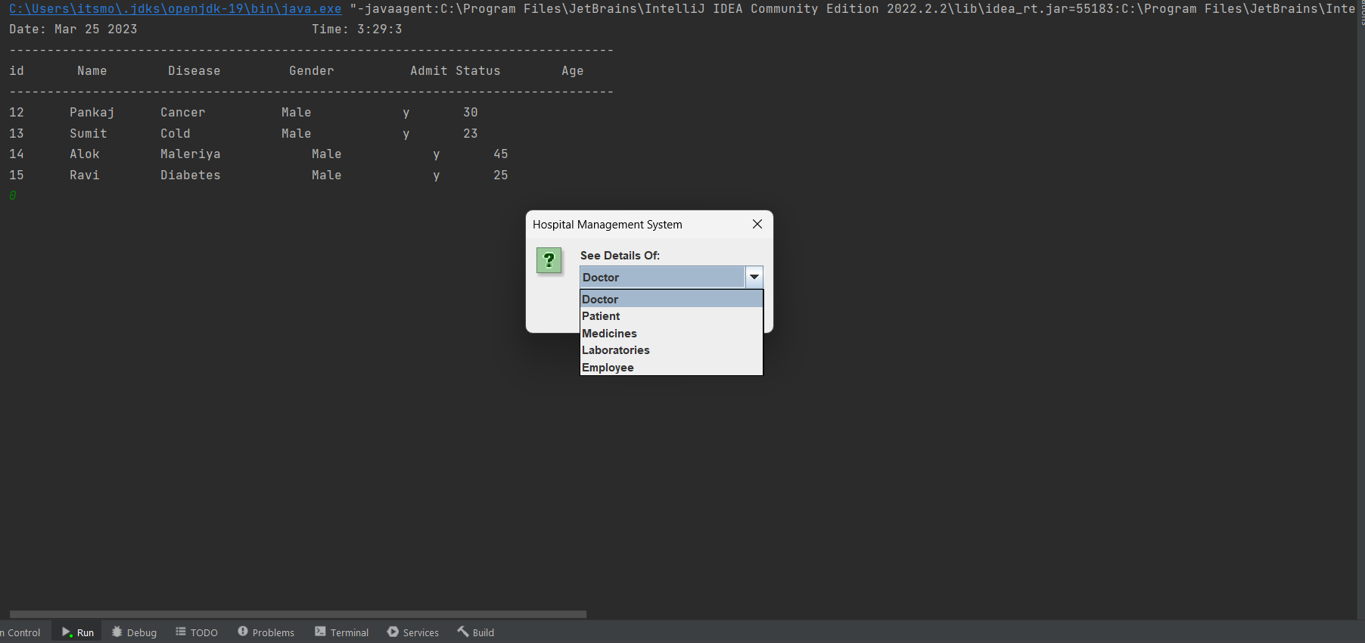

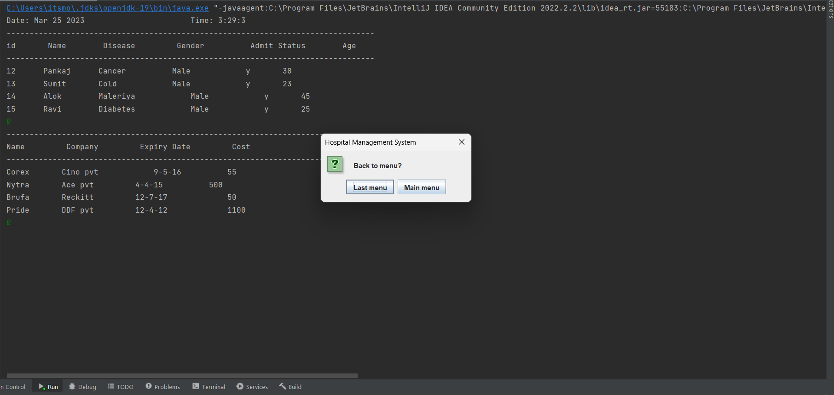

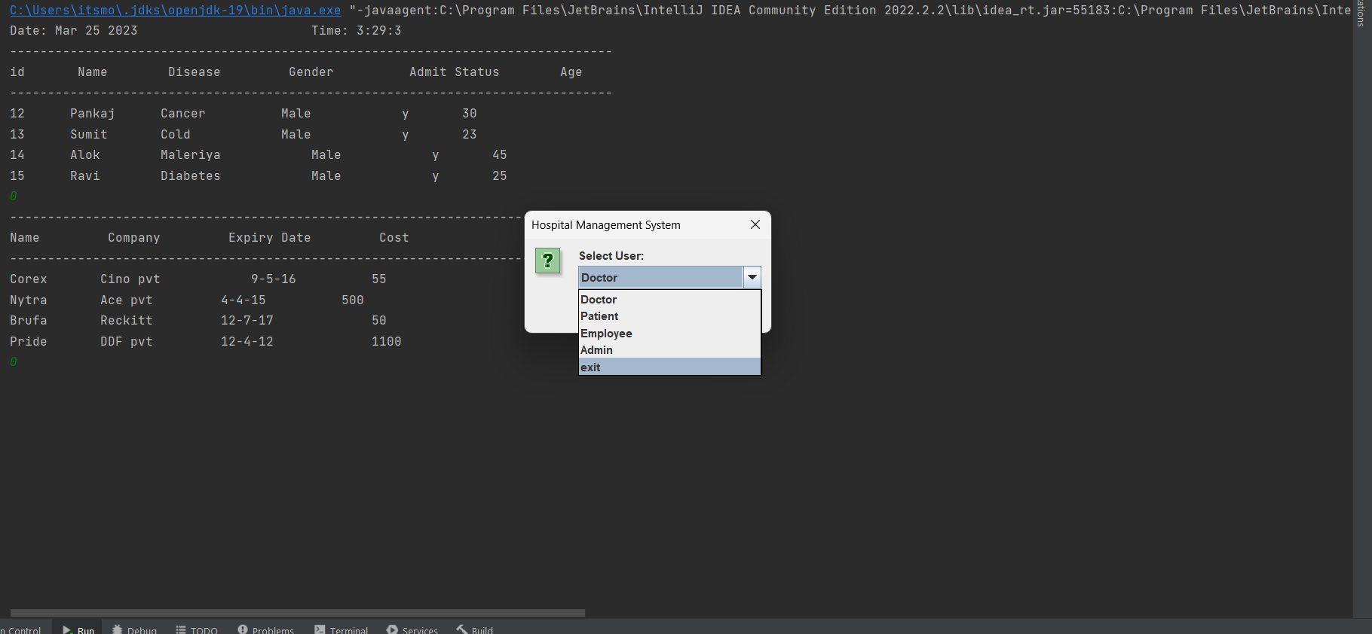

In this system Doctors and patients can only see the details but employee can make changes like add a new patient , new medicine, new features ,but the Admin have full control of the system and can make change in every thing so the steps are in arranged order: -

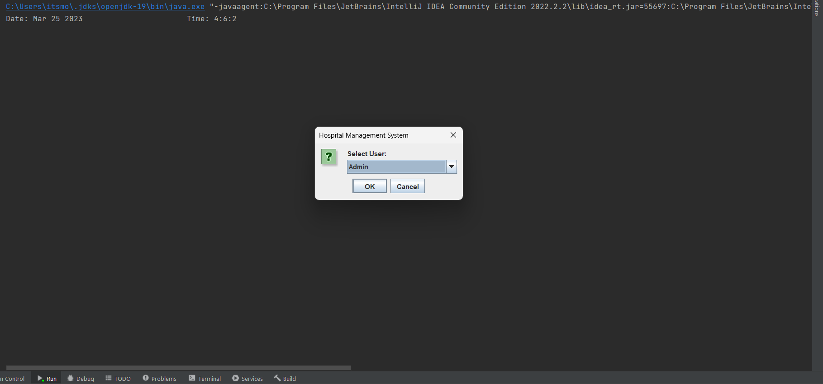

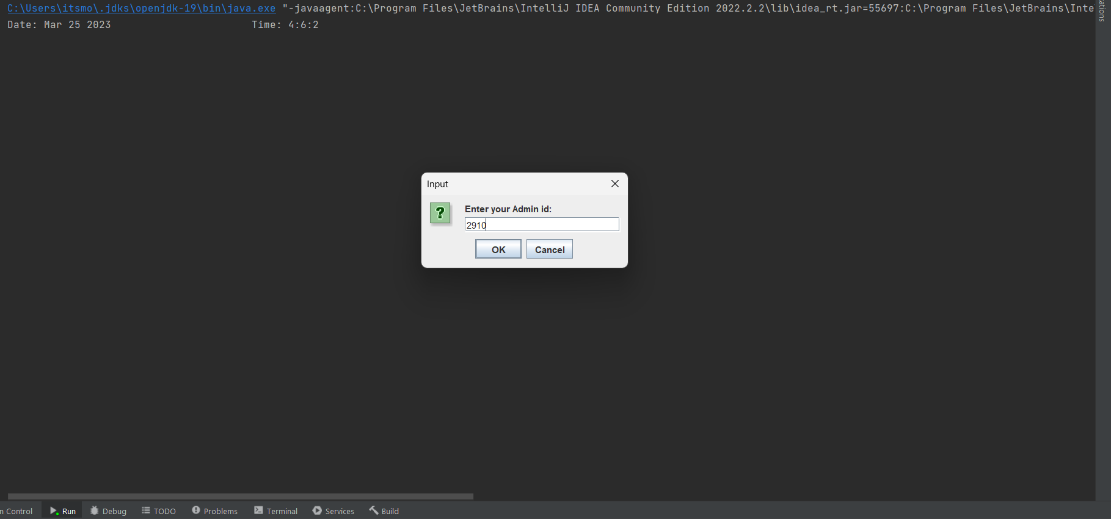

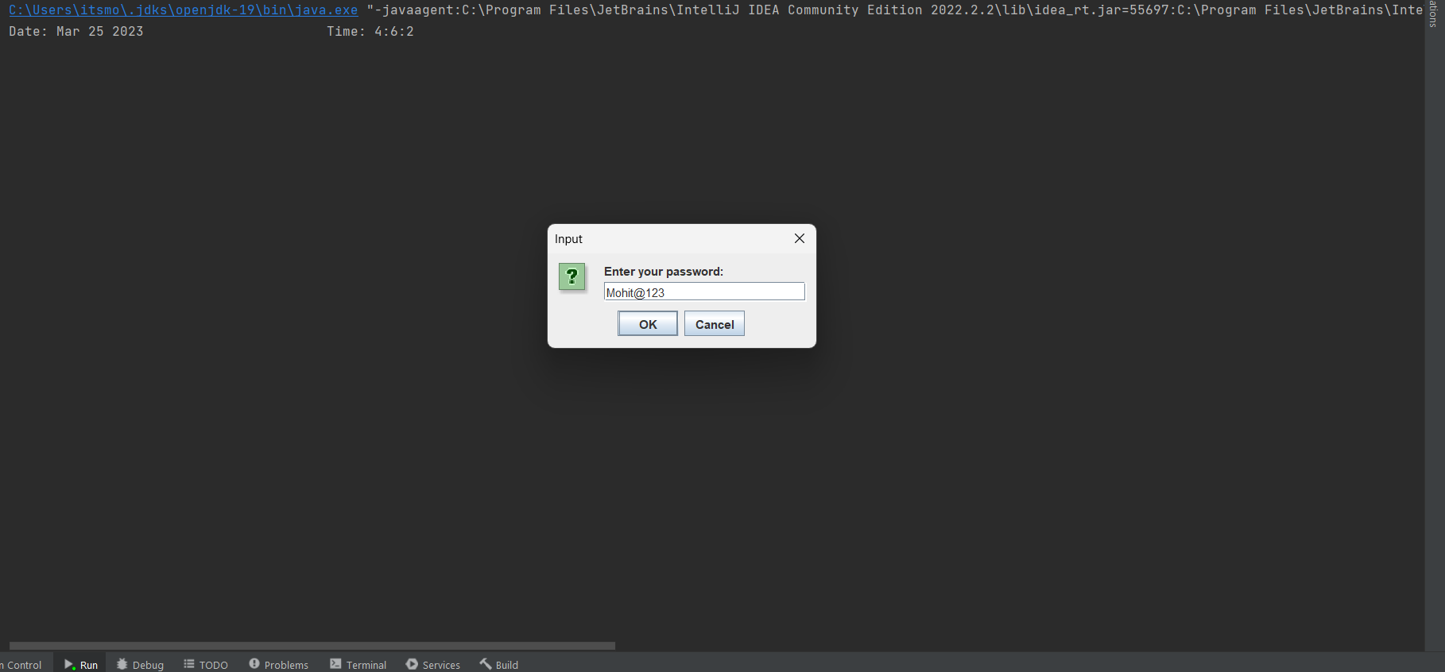



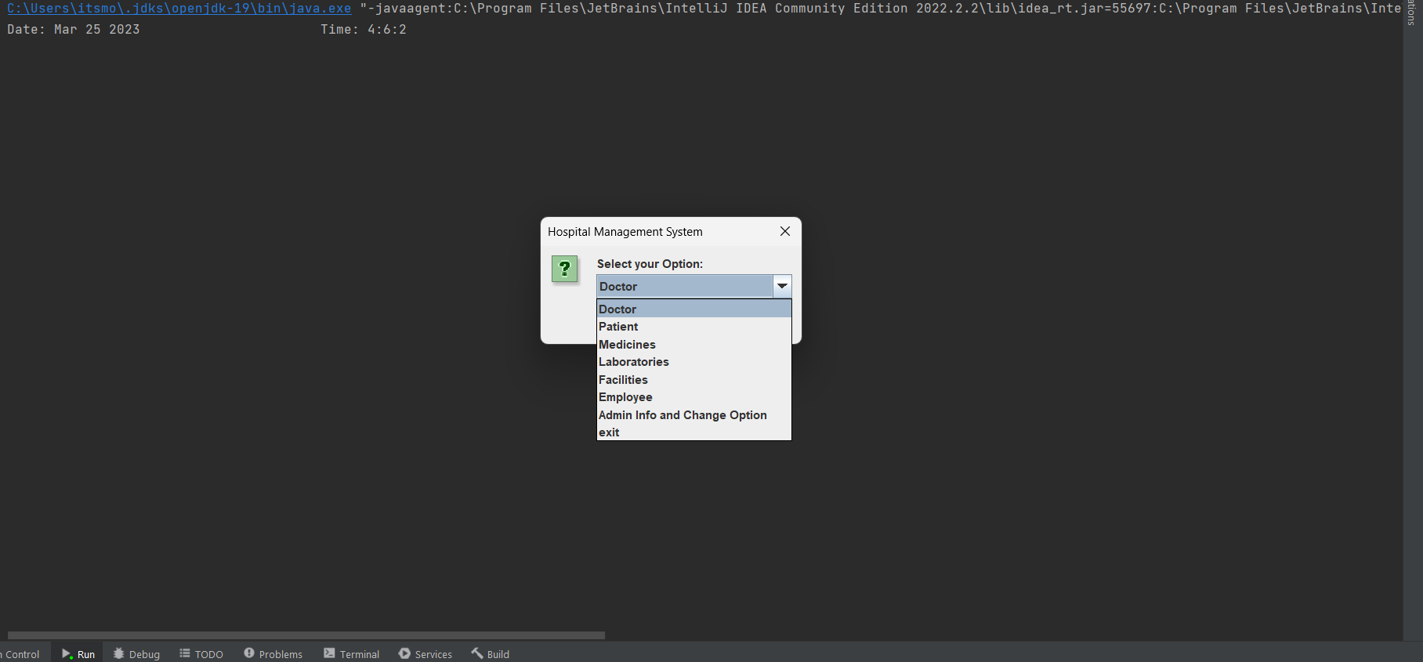

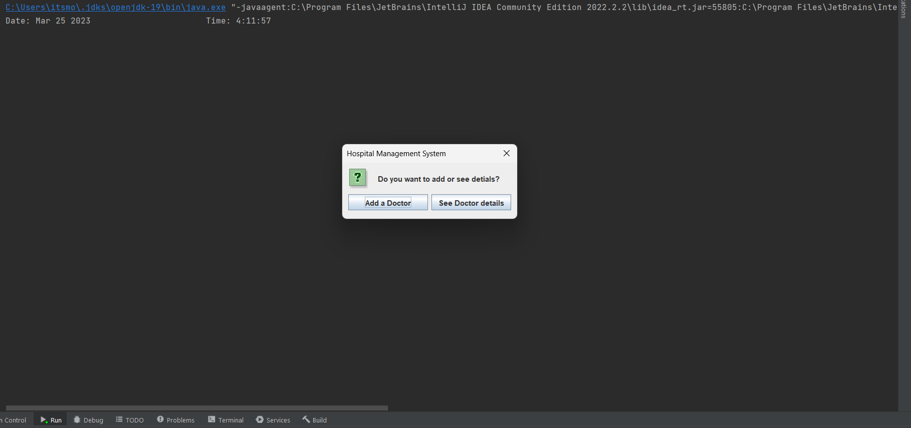

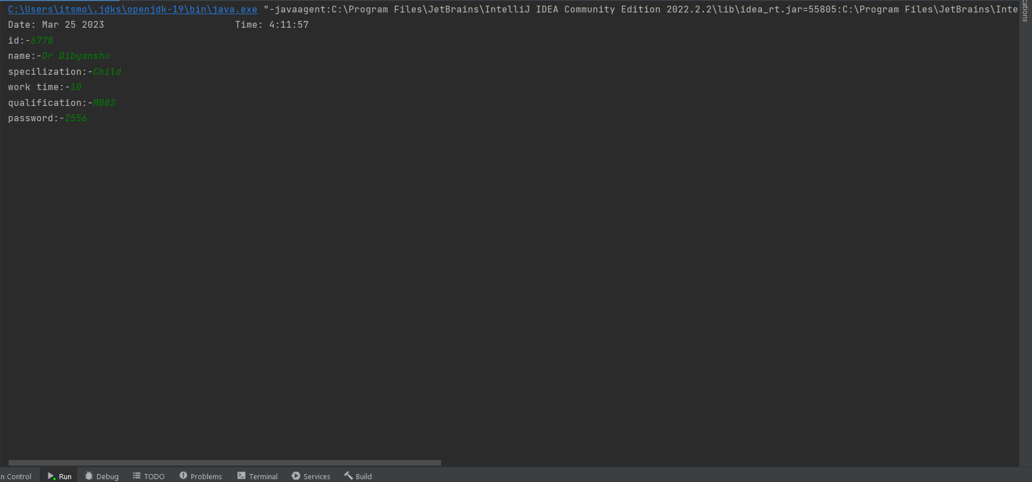

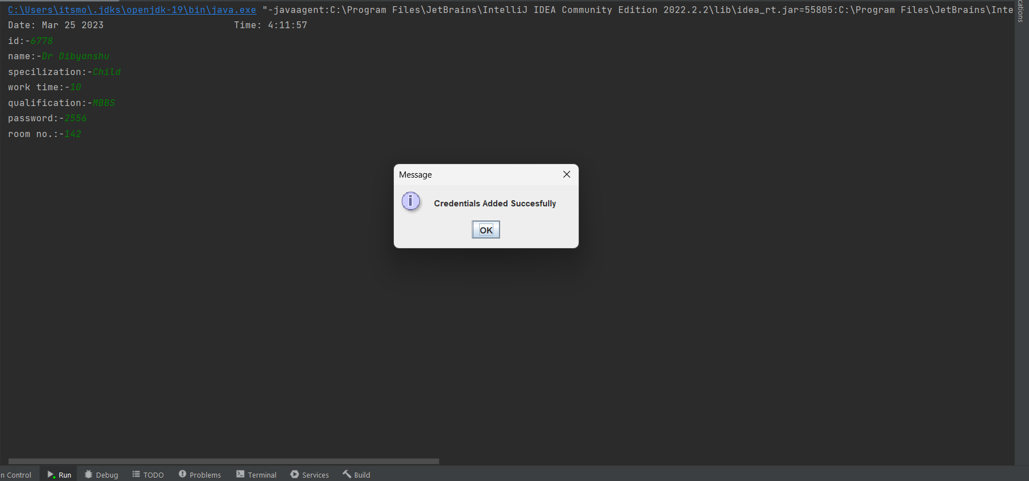

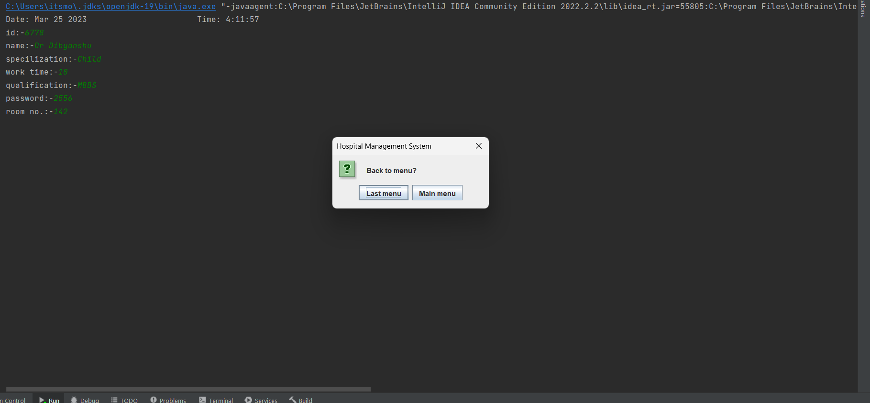

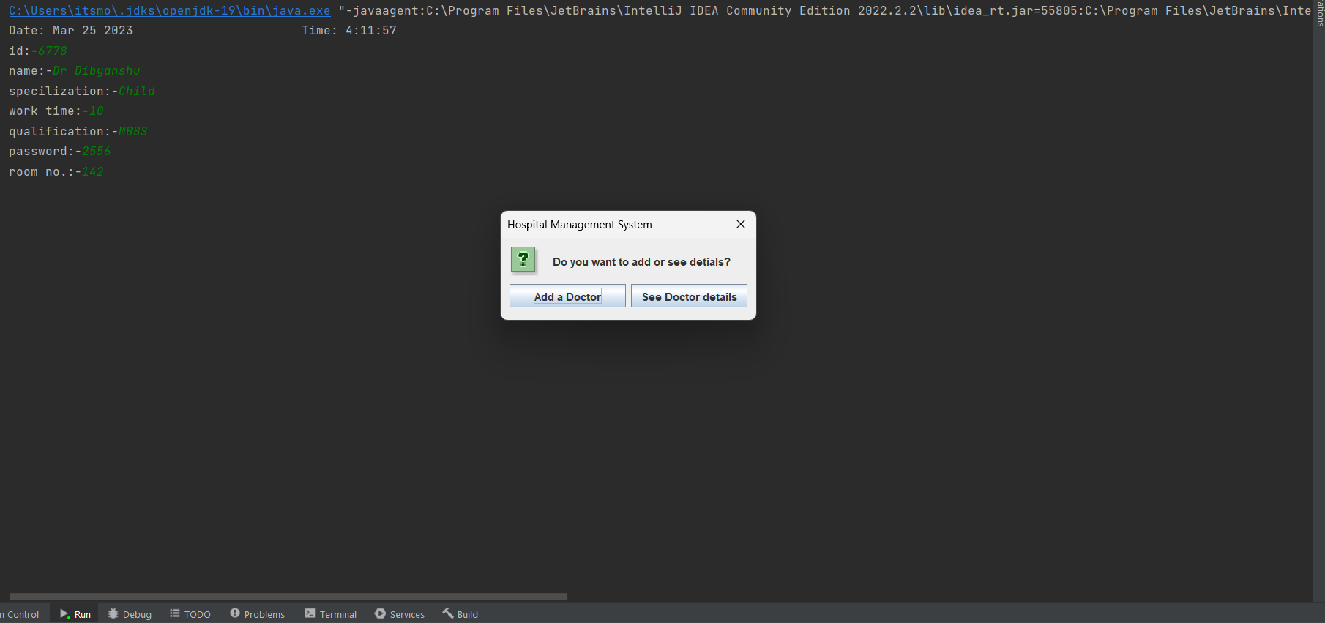

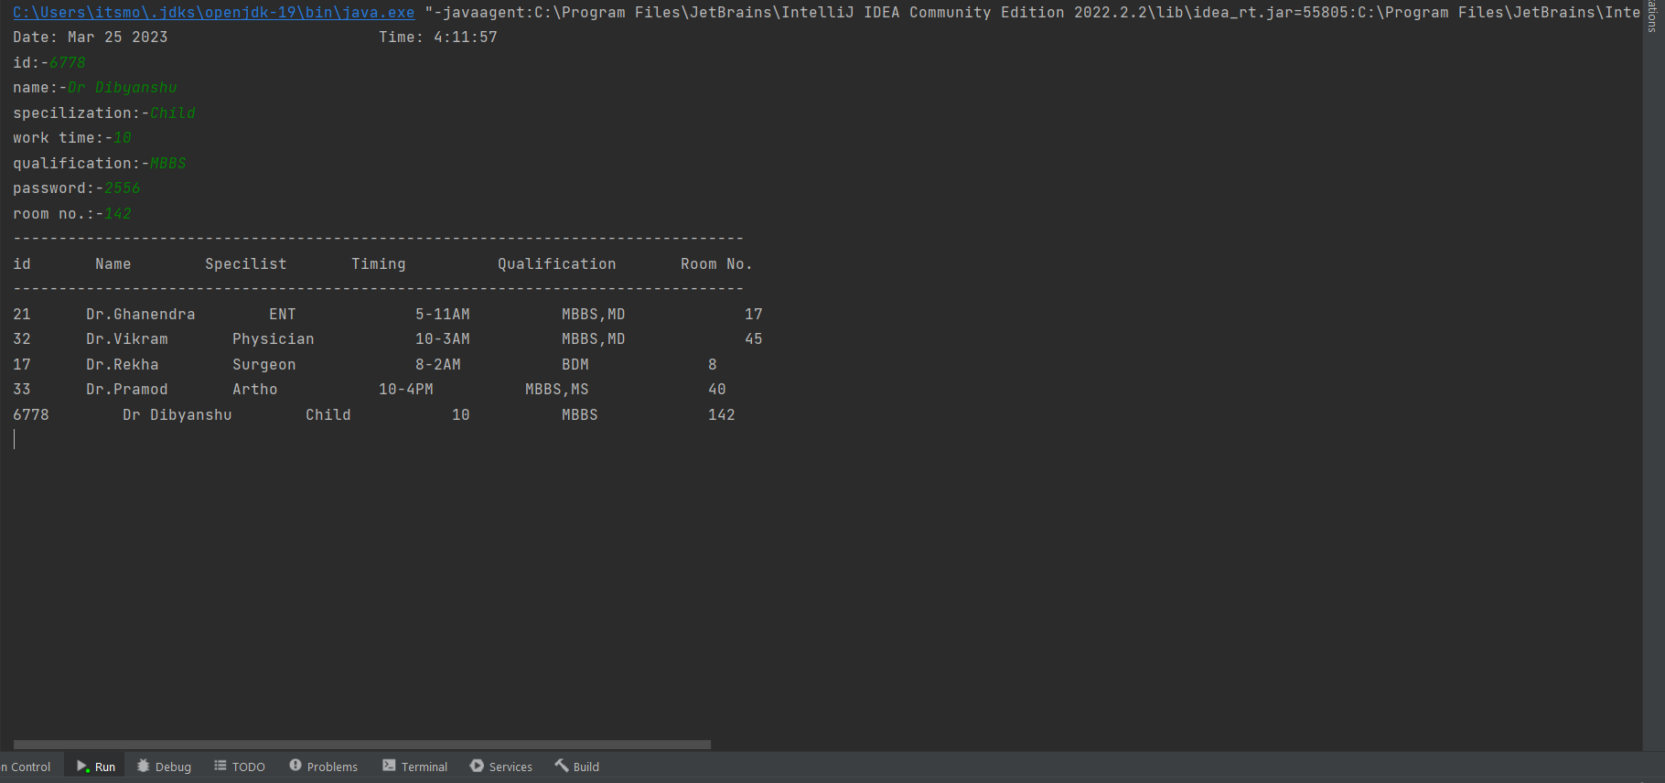

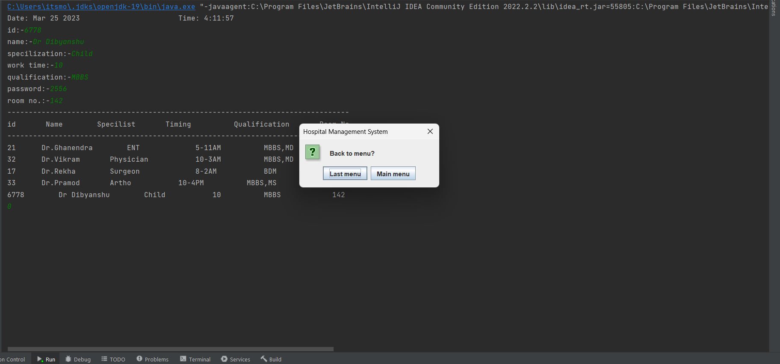

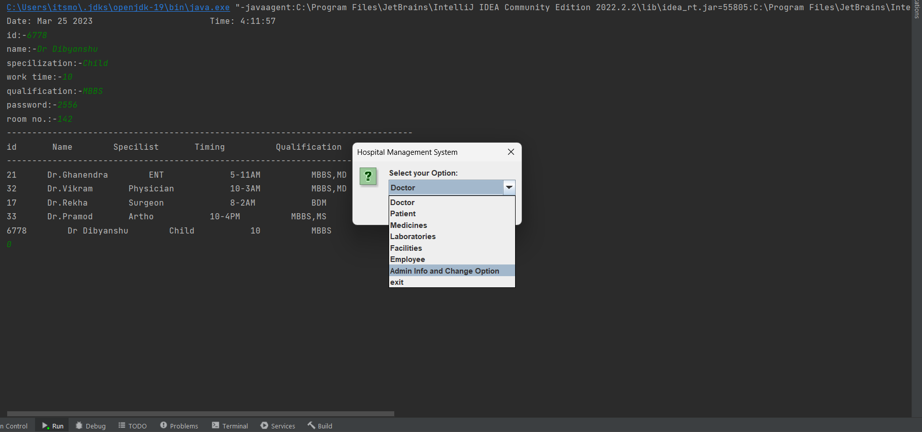

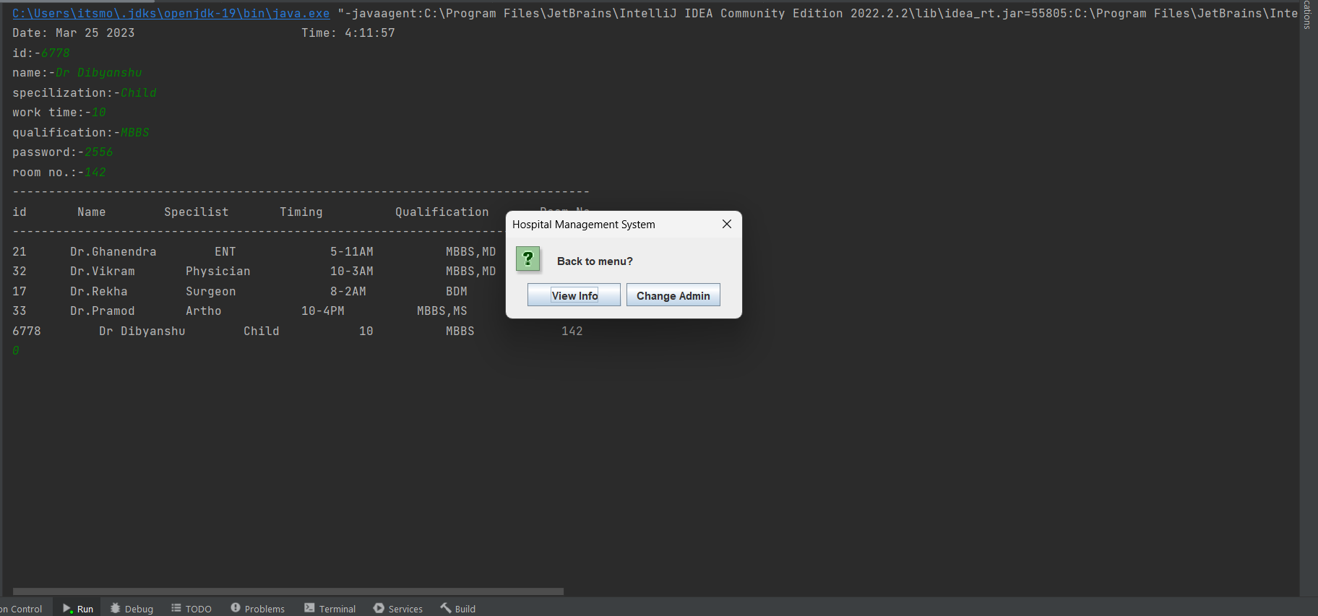

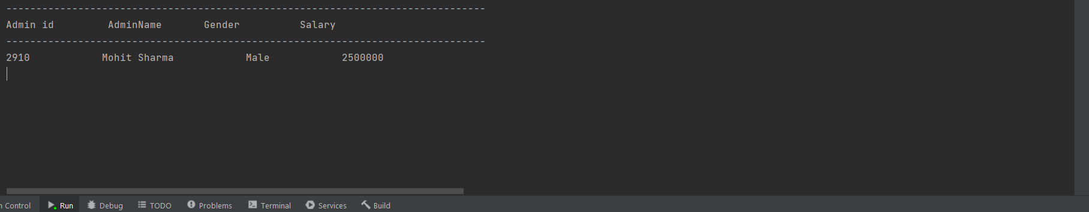

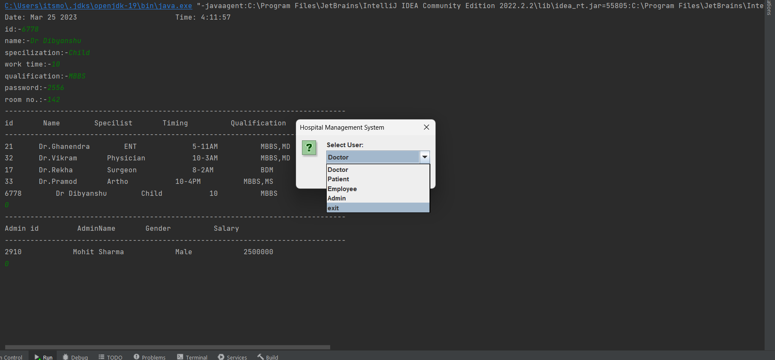

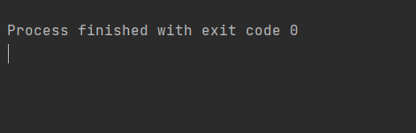

This is how the basic prototype of Hospital Management System works .

**Thank You**